

**DEVELOPMENT OF MODERN OF WEB APPLICATIONS**

VÝVOJ MODERNÍCH WEBOVÝCH APLIKACÍ

**THANH TUAN NGUYEN**

Bachelor Thesis

Supervisor: Ing. Michal Radecký, Ph.D.

Ostrava, 2022



**Abstract**

The aim of this thesis focuses on nowadays platforms of web applications development. This thesis gives manual, how to select a proper technology framework and how to use it. Besides, with the variety of website development, programmers or designers can self-study, research and develop their own products, students can understand the daily development of web development. web application development platforms and may be updated from time to time.

**Keyword**

HTML, CSS, JavaScript, React, web applications development, framework, Web Development

**Abstraktní**

Tato práce se zaměřuje na současné platformy vývoje webových aplikací. Tato práce poskytuje návod, jak vybrat správný technologický rámec a jak jej používat. Kromě toho, s rozmanitostí vývoje webových stránek, programátoři nebo designéři mohou samostudium, výzkum a vývoj vlastních produktů, studenti mohou pochopit každodenní vývoj vývoje webových aplikací. platformy pro vývoj webových aplikací a mohou být čas od času aktualizovány.

**Klíčové slovo**

HTML, CSS, JavaScript, React, vývoj webových aplikací, rámec, Vývoj webu

I would like to thank Ing. Michal Radecký, Ph.D. for his guidance, professional support for me to carry out my bachelor's thesis, and useful advices to carry out this thesis.

**Contents**

1 INTRODUCTION 10

2 WEB DEVELOPMENT 11

2.1 Trends in Web Development 11

2.1.1 Blockchain Technology 11

2.1.2 Progressive Web Apps (PWA) 11

2.1.3 WebAssembly 12

2.1.4 Personalize content with Machine Learning 12

2.1.5 Cyber Security 13

2.1.6 Dark Mode 13

2.1.7 JavaScript Frameworks 14

2.2 What is “web framework”? 14

2.3 Front-end framework 15

2.3.1 HTML5 15

2.3.2 CSS3 19

2.3.3 JavaScript 22

2.4 Popular Front-end frameworks 23

2.4.1 CSS Framework 23

2.4.2 JavaScript 29

3 WAY OF WEB APPLICATION DEVELOPMENT 40

3.1 Operating system 40

3.2 Framework 40

3.2.1 HTML5 40

3.2.2 ReactJS 40

3.3 SASS 40

3.4 Tool and other software 41

3.4.1 Redux 41

3.4.2 Boxicons 41

3.4.3 Photoshop 41

4 CASE STUDY 42

4.1 Index Page 42

4.1.1 Carousel 43

4.1.2 Product 43

4.1.3 Banner 44

4.2 Product Page 45

4.2.1 Product Card 46

4.2.2 Filter 46

4.2.3 Preview Product 47

4.3 Product Detail 48

4.3.1 Information of product 48

4.3.2 Image 49

4.3.3 Description of product 49

4.3.4 Related product 50

4.4 Cart Page 50

5 IMPLEMENTATION 52

5.1 Index page 52

5.1.1 Carousel 52

5.1.2 Popular Product 54

5.2 Product page 55

5.2.1 Filter 56

5.2.2 Product Card 57

5.2.3 Product View Mini (Quick Buy) 58

5.3 Detail page 60

5.3.1 Description 60

5.3.2 Scroll 61

5.4 Cart page 62

5.5 Other Important Components 64

5.5.1 Layout 64

5.5.2 Header 64

5.5.3 Footer 66

5.5.4 Load Data 66

5.6 Apps for mobile devices 67

6 EVALUATION 69

7 CONCLUSION 71

References 72

**List of symbols and abbreviations**

HTML - Hyper Text Markup Language

CSS - Cascading Style Sheet

JS - JavaScript

AJAX - Asynchronous JavaScript and XML

JSX - JavaScript XML

DOM - Document Object Model

API - Application Programming Interface

CDN - Content Delivery Network

UI - User Interface

XHTML - eXtensible Hyper Text Markup Language

NPM - Node Package Manager

**List of Figure**

Figure 1 : HTML5, JS and CSS 15

Figure 2 :Structure of HTML 19

Figure 3: CSS 20

Figure 4: Ranking using CSS Frameworks 29

Figure 5: Ranking using JS Frameworks 39

Figure 6: Home Page 43

Figure 7: Carousel on Index page 43

Figure 8: Slider for product in Index page 44

Figure 9: Some banner of product 45

Figure 10: Product Page 45

Figure 11: Product Card with effect 46

Figure 12: Some design of filter 47

Figure 13: No Quick Buy function on Product Page 48

Figure 14: Product Detail 49

Figure 15: Description for product 50

Figure 16: Cart Page 51

Figure 17: Carousel and Policy card 54

Figure 18: Result of random product 55

Figure 19: Product Page 55

Figure 20: Product View Mini (Quick Buy) 60

Figure 21: Product Detail 60

Figure 22: More and Collapse 61

Figure 23: Cart page 64

Figure 24: Header component 65

Figure 25: Footer component 66

Figure 26: Load data 67

Figure 27: Test filter on mobile devices 68

Figure 28: React operations 70

**List of Listing**

Listing 1: How to use Tailwind CSS 25

Listing 2: How to use Foundation CSS 28

Listing 3: Carousel in homepage 52

Listing 4: Carousel component 53

Listing 5: Animation shape background Carousel 54

Listing 6: getProducts 54

Listing 7: Show random products 55

Listing 8: Filter Function 57

Listing 9: Loop filter to show 57

Listing 10: Loop Product Card to show on Product page 57

Listing 11: Product Card component 58

Listing 12: Create list of products 58

Listing 13: Button on ProductCard component 58

Listing 14: Product View Modal components 59

Listing 15: See More button in ProductView component 61

Listing 16: Product for scrolling and related products 62

Listing 17: Alert 62

Listing 18: createSlice for adding, removing and updating in Cart page. 63

Listing 19: Total product and price 64

Listing 20: Layout 64

Listing 21: Set up list page will display 65

Listing 22: Header will go when scroll down 65

Listing 23: Load data when scroll down 67

Listing 24: Filter application for mobile devices 67

# INTRODUCTION

Technology is always changing over time, every day that passes can have a new technology born. Web too, web technology also changes over time and there are always certain changes to bring more optimization, modernity and convenience.

Web-related subjects and disciplines are increasing and growing especially those related to Web Development, two popular disciplines related to Web Development are Graphic Design and Computer Science, and Why is this subject so influential to so many people? Because people always use the Internet and Website every day, it is almost an irreplaceable necessity. So, the disciplines of Web Development gradually evolved, motivating more students, developers to learn and build many websites with many different topics and fields. Besides, with the development of the Web, which prompted them to create many frameworks.

Today, many frameworks are born with more convenience in use and implementation such as React, Vue, ... Or frameworks that are very familiar to us like basic HTML5 (HTML, CSS, JavaScript). As a basic programming student, you can learn C because it is your first programming language, but nowadays you can also choose C#, Java, C++, ... for programming languages. First of all, web applications are ours today. There are also many choices of frameworks such as React, Vue, Angular, ...

With a complete analysis and understanding of frameworks, users will find and choose the right framework to build websites from a personal perspective.

Many frameworks appear and are popular, along with the support of the community to strengthen and develop the frameworks, we can also be more confident in the process of using those frameworks because when we have difficulties or If there is a problem during use, a strong community with many experienced programmers will help us fix and fix it easier.

Therefore, this thesis will focus on analyzing web application development platforms, giving examples, advantages and disadvantages, which are the most popular, most downloaded and most popular platforms, etc. provides readers with basic usage of some popular and convenient technology frameworks.

The main sources and content of this thesis are used on w3schools[1] and also based on my experience as a designer.

# WEB DEVELOPMENT

## Trends in Web Development

Today, developers gradually build and create innovative and breakthrough applications and products. Over time, those products and applications become "phenomenon" and create a trend that many programmers have to follow and develop many other versions of products, promoting Web Development to become more popular. developed strongly, gradually giving birth to new trends in human interface, language and thinking. If you're a business owner using digital marketing, it's important to foresee these changes and adapt to them- so you can keep up with your competition and attract more customers.

In the future, people will see a lot of web development technologies and trends in the future. Those trends will certainly shape the way users experience the web, so what users need to experience in these trends is to improve their website rankings, take them to the next level and take that as an advantage to develop your career and business.

So what trends are developing and what are Web Developers trying to call resources and communities to participate?

### Blockchain Technology

Referring to Blockchain, many people will immediately think of "Bitcoin". A boom in 2018. At that time, in Telegram group chats, it was common to see: "go to the moon", "hold to die" of all kinds. In the end, "go to the hell", I lost. Well, "everyone has a dream to cherish".

Blockchain [4] technology opens a new trend for fields such as finance and banking, logistics, electronics and telecommunications, accounting and auditing...

Not only that, Blockchain is also the core of the Internet of Things (IoT). Electronic devices can communicate securely and transparently, nefarious attempts in the Internet world will fail, and much more…

Currently, there are many large companies and corporations that are building their own Blockchain network. So, we'll soon see how this can make waves in the future.

But the use of Blockchain is becoming significantly active in the last decade and major payment systems have decided to accept Bitcoin and other currencies. So what benefits does it bring to developers in the Web Development field:

* Blockchain provides a high level of security, eliminating any application and web development fraud. Only accurate data will be provided and transferred from one place to another and thus any fraud will be prevented from happening.
* The blockchain system is decentralized and, therefore, less prone to errors.
* Data can be transmitted over the network without going through an intermediary.

### Progressive Web Apps (PWA)

Appeared in 2015, Progressive Web Apps are web applications that are uploaded and work like regular web pages or websites built using common web technologies such as HTML and JavaScript, but it also provides giving users features like: working offline (working without internet), push notifications (sending and receiving notifications) and accessing the device's hardware which is usually only possible with native applications.

Some examples of Progressive Web Apps today: Tinder, Ola, Trivago, 9GAG, Alibaba, 5 Miles, ….

PWA is a web standard that gives users the feeling of using a native mobile application. And more specifically, users do not need to download and install it from the app-store or play-store.

There have been many large companies that have taken the lead in building Progressive Web Apps and it has helped them increase their visits and customers significantly. That is why in the coming years PWA web applications will become popular.

This technology allows web developers to combine the features of websites and mobile apps to:

* Create rich user experiences.
* Increase user engagement and conversion rates.
* Has relatively low development costs.
* Can be used without dependence on application distribution services such as Appstore or Play Store.
* Provides quick installation features and automatic updates.

### WebAssembly

When building a web application, performance is often compromised. JavaScript limitations make heavy calculations slow, and that affects the user experience significantly.

This is why most popular games and powerful applications are only available as a native desktop application.

WebAssembly[26][27] was born to change that - aiming for the same performance across web applications on all browsers and platforms. With WebAssembly, code in any programming language can be compiled into bytecode that runs in the browser.

WebAssembly has found many uses in online editing, ... So, the benefits this technology brings to these developers are:

* WebAssembly can execute on any web browser,
* Code can be executed at near-native speed.
* WebAssembly supports many programming languages.

### Personalize content with Machine Learning

Content personalization using machine learning is an advanced AI-based approach to dynamically display the most relevant content to each user. Artificial intelligence, including machine learning, affects our daily activities on the internet without us even realizing it. This is the point of machine learning - providing an improved experience natively.

Machine learning is the ability of software to improve performance without direct input from developers that helps users personalize content without targeting entire user segments. Basically, the software analyzes incoming data, detects patterns, makes decisions and improves its work.

Besides personalizing content with Machine Learning's advanced capabilities, what are the benefits developers can leverage this technology for:

* Analyze paths for site navigation, ...
* Optimizing web pages just got a whole lot easier.

### Cyber Security

Cyber security is mainly focused on protecting systems, networks and data from cyber-attacks. Effective cybersecurity reduces the risk of cyberattacks and protects organizations and individuals from unauthorized exploitation of systems, networks, and technologies. Cybersecurity will gradually become more important in 2022 because, while developers are automating more processes, their data is at risk of being stolen. The latest and greatest technologies in this area include the development of algorithms that help protect users from phishing attacks. And also, a way to develop Web Development safely.

Cybersecurity helps developers with the following benefits:

* Developers can use web back-end frameworks like Django or Ruby on Rails to avoid dangers like Cross-Site Scripting (XSS).
* Precautions can be taken by using strong encryption techniques to protect sensitive data.
* Analyze possible attacks by monitoring, tracking suspicious activities and finding ways to prevent such attacks.

### Dark Mode

Dark mode has become more popular than ever, almost any software, application and website apply dark mode to its products, but it will not be until 2020 to 2021. mainstream in web development. Dark mode binds to the palette to create symmetry with other light colors.

With dark mode can help users avoid sore and sore eyes when working for a long time, and make the website more modern and accessible to users.

Users can see that in recent times, dark background mode is increasingly popular and popularly used by technology users all over the world. Nearly every popular application and operating system from famous names such as Google, Microsoft, Apple and Android ... have introduced dark mode setting options. Many developers even recommend that users switch to completely using dark mode, if possible, because of the great advantages it brings. It is certain that dark mode will be an inevitable web development trend in 2022.

Dark mode is not only easier on the eyes, but this style also helps save battery life for mobile devices. Let's see the practical benefits of dark mode over light mode:

* Dark mode because its feature is to reduce light emitted from the screen, so it can help significantly calm the eyes, helping users to completely reduce the feeling of eye pain, especially in the evening.
* Dark mode reduces strong light and makes it easier to view content in low-light environments.
* When OLED screens display black, it will turn off those pixels instead of displaying black like LCD screens, so OLED screens using Dark Mode will provide better battery life. compared to LCD screens and device screens that use OLED but do not use Dark Mode.

### JavaScript Frameworks

The JavaScript Frameworks are in the process of standardizing and creating a convenient, easy-to-use generation system.

Since 2020, JavaScript Frameworks have flourished in regards to UX, UI, testing and product management aspects.

Technically, JavaScript Frameworks are still application frameworks created using the JavaScript programming language and based on built-in libraries (both visual and functional).

This web trend has a lot of benefits. Providing instant user responsiveness without page reload, high efficiency and fast performance, coding simplicity are just a few of them.

In addition to the JavaScript trend, TypeScript has emerged strongly as an alternative to JavaScript, it has advancements and improvements that JavaScript cannot change. And what is in the JavaScript framework, this content will be analyzed in detail in the following section.

Here are some notable benefits of JavaScript Framework in web development:

* Provides HTML templating, making it easy to read data in the markup.
* Provides component-based design that allows for reuse of content.
* The JavaScript framework gives your project a more detailed structure, ready to provide common programming solutions.
* JS Framework increases overall efficiency.

## What is “web framework”?

Framework are pre-written pieces of code that make up a set of frameworks and packaged programming libraries. They provide built-in features like mockups, APIs, and other elements to simplify the development of rich, dynamic web applications. The frameworks are like we have a pre-made house frame with the basic foundation, you just need to build and interior as you like.

For example: To create a racing game, programmers will have to create (program) wheels, bodywork, people, roads, ... and then start assembling the creation parts. out space for the game. But if we have the frameworks available, we just need to take them out from the framework and reassemble, it will be fast and save a lot of money.

It can be understood that frameworks are pre-made materials for users to use, and just understanding the rules can create optimal products depending on the perspective of programmers.

Programmers or students just starting to learn web programming can use frameworks to be able to create products according to their personal preferences, just need to understand the operating rules of those frameworks. will be easier to use.

In web development framework, there are two types: Front-end framework and Back-end framework.

## Front-end framework

In simple terms, in web design, the front-end is created by three basic languages, which are HTML, CSS, and JavaScript. Programmers are not just web designers, but must make the designed web applications compatible with other types of devices and screens, possibly different operating systems.

Front-end frameworks are packages of pre-written code to apply. It's like a coding dictionary made to help you quickly perfect your application without having to code it yourself.

In the front-end framework, there are two types of frameworks but can be used together to optimize the application, product and user interface. Those are CSS framework and JS framework.

When it comes to Front-end, users always think of the famous trio of HTML5, CSS and JavaScript and I will focus a lot on the Front-end framework. Figure 1 is a trio of commonly used web programming languages, and since then many different libraries and frameworks have been born and help users choose the right libraries and frameworks for developing applications.

Below are the functions, information about HTML, CSS, JS and some frameworks that come with it, because users have to understand what they are, what they can do for Web Development. Because when users understand this basic information, users will be able to choose frameworks that are suitable for themselves, in accordance with their abilities.

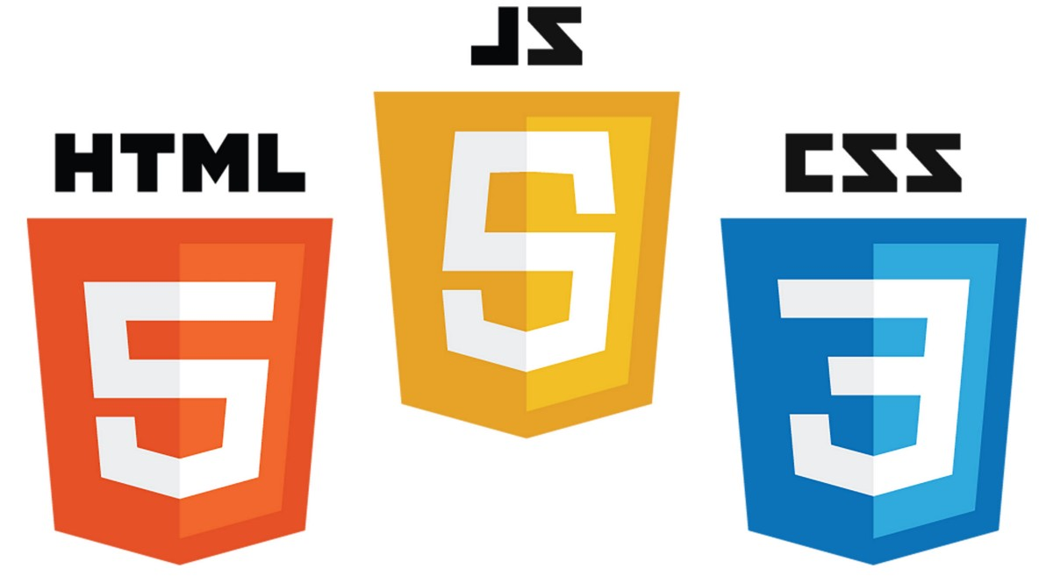

Figure 1 : HTML5, JS and CSS[2]

### HTML5

#### What is HTML5?

HTML5 [1] [2] [5] is an upgrade of HTML (HyperText Markup Link) which is a quality HyperText Markup Language for web browsers, this is a language that allows creating web pages on many web browsers such as Google Chrome, Microsoft Edge, ...

When HTML was born, the difficulty that programmers faced was that some web browsers would be incompatible or not work well. So different browsers when displaying web pages will always have their own way of working and compatibility, including mobile browsers, tablet browsers, etc. Programmers are always thinking and finding ways so that the HTML works fine on all web browsers without any difficulty. But when the HTML5 [1] version was released, those difficulties have been overcome and provided many features that bring many conveniences and benefits to developers.

The features below, are the basic features of an HTML, users should grasp if they want to start learning about Web Development because HTML, CSS and JS are one of the three basic languages of Web Development and everyone must know, so users must understand the features of HTML if they want to go deeper in Web Development.

#### Features of HTML5

These are the most commonly used and most used features in the apps by students, programmers and developers.

Features [1] like Header, Footer, Graphics [3], ... are newly updated functions in HTML5 version, and they are used frequently by developers in the project, and gradually improved in frameworks. Users can base on this basic information to try out these functions and learn more.

* Media Support

With HTML5's <video> and <audio> tags [1], we can create multimedia[3] elements without depending on Adobe Flash or third-party software to intervene and support, all now just What you need is a web browser. Another way to reduce the load on hosting is to upload the video to a 3rd party site like Youtube and embed it on your website. This is the most optimal way, because Youtube will support the play frame to suit the device.

* Responsive – HTML5 is compatible on all devices

One of the most "divine" features is that HTML5 is compatible on all devices. It's not just a computer, laptop, tablet or phone, but it can be a TV or other device. Users who have a link, you can view that website on anywhere, any device. Except in case the user is using the application on the phone (app). Some popular Google applications such as Gmail have just had a web application that is compatible with all devices, but they still develop mobile applications (applications) to make it more convenient for users.

* Free

To program a certain language, the user must have an environment or software to do the typing. But for HTML5, users only need a notepad file right on the computer, after writing it, save it in HTML format and open it in a browser, the user has a website. There are many free applications that support typing code to make it easier for users to manage such as notepad++, Atom or Eclipse. They will support code coloration and also which code is a child of which code. TinoHost is more in favor of using software like this because they are professional in each operation with the code, but edit it as if typing like Word "lost"…

* Clear structure division

With new tags like: <header>, <section> or <footer> among others, the partial structure of the HTML document becomes clearer than ever. Not only providing content, but also creating semantics for the entire website.

A clear division between tags and content makes it easier for developers to find mistakes.

* New syntax elements in HTML5

From early HTML versions. Gradually versions of HTML are updated, and with each version, there are updates and improvements that make the language more convenient. HTML5 is an example, new tags, programming methods, ... all become neater and more convenient, so the operations help users perform better. And this is an advantage for new developers and users alike, neatness makes learning HTML5 easier and more convenient.

* Geolocation API

The HTML5 Geolocation API allows users to share their location, so if the user approves, the feature will only be available. JavaScript can capture the computer's latitude and longitude information and send it to the webserver.

That's why when we use Google Maps, we always know where we are, and the server will ask if we agree to share our location.

Today, browsers and mobile devices always have API support for location sharing.

* Rich HTML tags

To introduce all the other tags and functions like Table, Iframe, Symbol, Links, List, ... it may be necessary to write a detailed manual because they belong to the way of thinking that the user can apply them to your project but users can also refer to those functions themselves. Besides, the tags and functions introduced above are one of the new HTML5 tags and functions and one of the essential tags in web projects. So, users want to learn and go deeper into Web Development, users must learn and use more about HTML5 tags and features proficiently.

To learn and understand HTML, users must also understand the advantages and disadvantages of HTML so that they can overcome and take advantage of those advantages and weaknesses, making their projects more optimal when use.

#### Advantage of HTML5

HTML5 is used by many developers and is an indispensable language in web programming in particular and web development in general, so what benefits does it bring that can retain so many developers.

* Maximized source code and new bookmark tag

HTML5 is the latest version, the version is considered the most optimal. HTML5 is a version that has improved the difficulties and disadvantages of previous versions clearly. The first and most basic features are the cards. HTML5 has provided users with many new and convenient things, from content tags (title, aside, article, ...) to multimedia tags (video, audio, ...). In addition, HTML5 also gives users the ability to clearly allocate positions through surveys and the way that users design a web page must ensure the basic elements (header, footers, ...). Creating tags that can manage locations for a website makes it easier for developers to manage the functions on the site, and visitors also have a positive view of the ease of access. site or use. The <form> tag is a widely used tag because all functions such as formatting, data validation, ... are integrated directly into the HTML. Old-fashioned technologies like Adobe Flash will no longer be supported.

* Offline Browsing

There is not always internet 24/7, this sometimes also makes users uncomfortable. Offline Browser is a feature that helps to store offline cache in the browser, allowing users to access the website without having to be online. This also makes the site save bandwidth and speed up web browsing.

* Video and Audio tags

In previous versions, developers always had to buy and use software like Adobe Flash Player, Silverlight to embed video or audio in websites and use complex tags like <embed> and <object>. These methods are often not available and cross-browser compatible, and when bugs appear, they are difficult to fix. HTML5 offers positive solutions by integrating libraries and convenient, compact tags, such as <video> and <audio> tags. It is also simpler to use and the attached properties are not difficult for developers, thanks to the features that developers can easily use, reducing the load on resources and the computer will work better and faster.

* Cross-browser operability

HTML5 will provide simple declarations and information, besides, HTML5 will also provide a more robust version of the API than the good ones. HTML5 is considered to work very well on popular browsers such as Chrome, Microsoft Edge, ...

* Canvas for Animation

To reduce complexity and take animation to another level, HTML5 has given a new card named <canvas>. Canvas, a feature embedded in HTML5 and part of the Document Object Model (DOM), opening up many animation options, allowing you to graph, add image effects, team game development route as well as offline, …

* Optimization on mobile devices

Mobile devices are almost indispensable in all cases, so optimizing for mobile devices is one of the advantages of HTML5 for users and developers, helping to display the interface. web application for mobile devices. Interacting, installing, adjusting, and building with HTML5 makes it possible for developers to develop on many different mobile devices and multiple operating systems.

#### Disadvantage of HTML5

HTML5 can be considered as one of the most optimal versions when it has improved the vulnerabilities, complexity, and disadvantages that previous version have encountered. All browsers have fully supported HTML5 up to the present time, so it can be assessed that HTML5 does not have any significant disadvantages.

And when we understand the functions of tags, the benefits and weaknesses of HTML, the user must also understand how the structure of an HTML should work and in what order, so that the user can build source code. in a way that is easier to understand and interact with.

#### Structure of HTML5

Figure 8 shows how to use HTML5, the basic functions and implementation of the syntax. The new features in HTML5 mentioned in the above sections will make it easy and convenient for developers to do programming work without having to depend on third-party software or other plugins.

Besides, if you know each HTML5, only frames can be created and the interface will have no colors or effects, so CSS is a second language that provides users with color interaction. CSS is to be presented below.

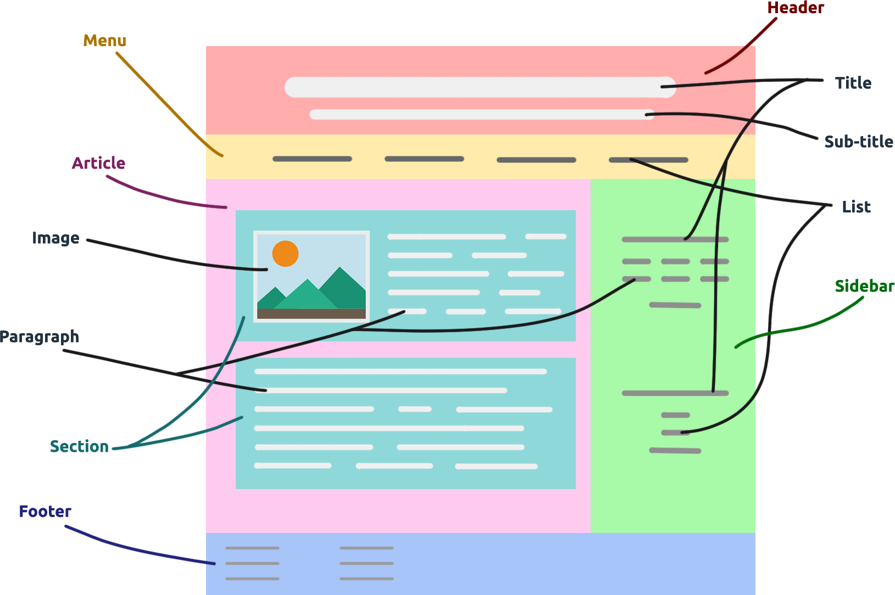

Figure 2 :Structure of HTML[3]

### CSS3

#### What Is CSS?

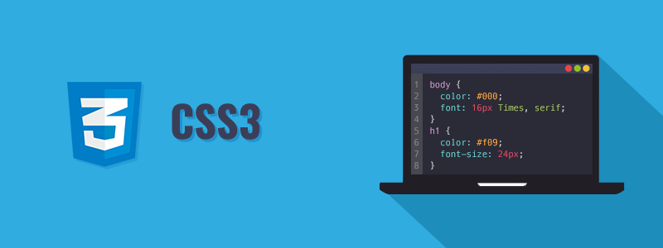

Figure 3: CSS[4]

CSS [5] stands for Cascading Style Sheets which is a style sheet language used to describe the presentation of a web page such as adding colors, effects, formatting, fonts, ... and the CSS file is also a file. browser support to display the page using HTML. Every website has its own style of interface design, like how to add color in buttons, how to add effects to buttons or cover pages, ... CSS is a file that can improve content accessibility, which provides more flexibility and control in defining presentation characteristics, allows multiple sites to share formatting by specifying the relevant CSS in a separate .css file, reducing complexity complex and repetitive within that structured content.

In one CSS file, we can adjust for all pages, like want to change the background color for all web pages, fonts, etc. Depending on how the developers want to build the website.

The interesting thing about CSS is that it gives users the freedom to be creative when using CSS, when users use CSS, users are like "flying in the clouds", because users can think of countless signals. application, color, size to a web application. It is this that has motivated developers to create frameworks specifically for CSS with the desire to create functions and provide pre-made color data to users, so that simple web applications can be created. Simple, fast but still gives the project a colorful user-generated creativity. One of the factors to promote the development of Web Development.

CSS3[23] can be seen as the latest version of CSS.

And to better understand the CSS "Universe", users should understand how CSS works, its features and benefits.

#### Features of CSS

To grasp and understand CSS, users must understand its features. CSS has a lot of features [23] , so below are features that are used, needed or updated in CSS3.

* Selector

CSS level 1 allows to combine elements by type, class or ID. For CSS3, you can completely target every element on the page with selectors.

In addition to expanding upon the attribute selectors introduced in CSS2. CSS3 added 3 attribute selectors that allow substring selection.

* Rounded corner: Border radius

CSS3 uses the border-radius property to create rounded corners without having to use images or additional markup. Example: border-radius: 14px;

* Linear Gradients

The user will use the syntax: background: linear-gradient(direction, color-stop1, color-stop2, ...); This way developers can create a linear gradient in CSS3 quickly. The direction of the upper gradient can be specified in degrees, by replacing “to right” with a specific number for degrees.

* Pseudo-classes

A Pseudo-Class is used to select elements in CSS3 to define state characteristics. Pseudo-Class technology allows users to add special effects to elements in the HTML tree without having to use JavaScript and usually begins with the ":" character like :link,: hover, :active, :visited, :focus . In the CSS3 version new Pseudo-Classes selectors have been added.

* Color

CSS Color is one of the important technologies used in almost all cases, besides color names such as red, blue, yellow, ... then we will be able to find color types that cannot be specified. through color coding. In HTML, color is always the choice and stimulates creativity besides animation, for designers.

#### Advantage of CSS3

CSS is a complementary language for HTML, these two languages are almost inseparable. So the advantage [15] of CSS for users are:

* Consistency

Users only need to use a single CSS file, all different pages in the same website will sync with each other. If the user wants to change, then just change the parameters and information in the CSS file, the website will sync again. That is the main advantage of CSS.

* Compatibility

CSS is compatible with many screens, so it will be more convenient for users without adjusting the displayed content, increasing the user experience.

* Easy to understand

Nowadays, users can learn and learn HTML and CSS on the internet. The layout and attribute information are clearly explained and easy to understand, making it easy for users to learn. CSS properties and HTML tags are separated by "class" and "id", which will not be confused by users.

* Common

CSS and HTML are languages ​​that are widely used and widely used in the world and are used in a number of browsers. Community is also one of the important factors for the maintenance and development of the language, HTML, CSS and JS are languages ​​with strong support communities in the world.

#### Disadvantage of CSS3

* Problems with some browsers

For some newer and less used browsers, there are some problems using CSS.

* Multiple CSS levels

There are three levels of CSS namely CSS, CSS2 and CSS3, which can be confusing for some newbies.

### JavaScript

Besides HTML and CSS, JavaScript is one of the indispensable languages in web programming and in Web Development. If a user wants to build an event for his website, then JavaScript is a language that helps to bring that to the user. With the convenience of JS brought, many JS frameworks have been born giving many users, diversity in construction, comfort in development, and freedom in creativity.

So, what does JS have that bring developers and users so many benefits, but also a great contribution to Web Development.

#### What is JavaScript?

JavaScript [22][24] is a dynamic programming language for creating content for web pages and is one of the most commonly used languages ​​in the world. JavaScript is integrated into HTML files, and created to increase interactivity and improve website performance.

JavaScript creates web page effects such as dynamic background colors, animations, ...

#### Advantages of JavaScript

JavaScript is one of the most used programming languages ​​in web programming, it is almost an indispensable language in web programming, developers are always developing this programming language, helping this language gradually become easier to use and more convenient for users.

* Execution on the client

When a user executes the code, the source code executes on the client machine instead of on the server, saving bandwidth and interruption on the webserver. Because if all the source code executes on the server, the server won't be able to process it in time.

* Simple language

JavaScript is a programming language that developers consider easy to learn. JavaScript uses the Virtual DOM to provide writing features for a variety of objects, making it easy for users to use and understand when dealing with a script.

* Quick interaction for users

When the user completes the code, the user can execute and the results are returned immediately. With fast results, processing speed makes it easier for users to interact and does not consume a lot of time and data on the server and the client.

* Richer interface

JavaScript provides users with a variety of interfaces to be able to create attractive web pages such as Drag and Drop (DnD) components or sliders. Helps improve user-site interaction.

#### Disadvantage of JavaScript

* Other client-side security

When JavaScript code is executed on the client-side, the results are returned almost immediately, so preliminary information can be exploited with malicious intent, malicious code can still work on the client-side.

* Browser support

JavaScript is one of the languages that is run on almost all browsers, but with very old browsers, sometimes it will not work, but this will not affect much if the user changes the browser or upgrade.

## Popular Front-end frameworks

### CSS Framework

CSS Framework is a set of CSS source code that has been pre-written with certain functions and declares each function in a separate class, programmers or designers will easily apply the functions to the product, their application by adding the class of the element they want to use on the element they need to apply it to, for example adding a style to a button or menu.

There are many popular and trending CSS Frameworks that many people use, develop and apply to projects such as Bootstrap, Tailwind CSS, ...

CSS Framework is the result of success in Web Development, because it brings convenience, simplicity to use. CSS is also the result of "creativity", developers have understood the needs and wants of users when using CSS. Because these frameworks help users to apply to websites faster and more optimally. However, it also requires a basic knowledge of CSS.

#### Tailwind CSS

##### What is Tailwind CSS?

Tailwind[5] [6] [7] is a utility-first CSS framework, it has built-in classes that we can use. Tailwind CSS has many classes that cover different CSS properties and importantly, we can easily extend and create new classes with its own classes. With Tailwind, customization is easier than ever. This framework has extremely detailed documentation, covering all the detailed usage of the class and showing various ways of customization.

##### Feature of Tailwind CSS

Tailwind has brought many very convenient features for users. So those features are:

* Efficiency

When using Tailwind, the system will delete the CSS that the user does not use to save space.

* Component Management

If developers are afraid of writing too long a piece of code on 1 page, when encountering a bug, then developers will lose time finding the error location. So when using Tailwind, developers can break down a website into many components in different documents and combine the documents, making it easier for us to manage and handle when there is a problem. And in terms of interface, this management will become neater.

* Dark mode

Many users and developers today all work on a bright screen, if working at night it will be harmful to eyes if the screen is too bright. So dark mode is a function that helps users switch the interface to black, dark colors so that they can not hurt their eyes.

* Ready-made components

To help users and developers build interfaces quickly, Tailwind developers have built a series of beautiful prototype components that fully meet the design requirements. and functionality, allowing users to use and combine components in a personal style.

* Using Basic CSS Components

If the user wants to use the basic CSS elements without having to integrate the same page with the HTML, the user can use the @apply command to extract it by copying the HTML file to the CSS file and adding the @ directive apply at the top.

##### Advantage of Tailwind CSS

* Save cache

If you are using a traditional CSS, you will feel that you are creating a function, excess layer but you can't know where it is to delete, this will make the buffer much and heavy. So when using Tailwind CSS, this will be removed because you will be done directly on HTML, and will automatically remove the functions, excess layers that you do not use regularly.

* Faster

Tailwind helps users style and write CSS directly on HTML instead of writing on another CSS file. Users can create compositions, interfaces, colors, ... beautiful in a much shorter time than having to do it from the beginning to the end.

* More security

When using Tailwind CSS, users will feel safe and your source code will not be corrupted because you are doing directly in the HTML file. Tailwind has been shown to be a stable and safe framework, because Tailwind is developed by the leading historical techniques, which is why the errors are very rare.

* Other features

Because Tailwind works directly on the HTML file, Tailwind provides the ability to create a response to web applications and remove unused CSS, making memory more compact, economical and easy to manage and modify in large projects.

##### Disadvantage of Tailwind CSS

* Take time to study

Since this is a framework that has already created classes and functions, it is definitely a must for new users to learn and learn more about its usage and scale. Even seasoned developers have to find a way to learn more and memorize new classes. But if we learn a lot and use it fluently, this disadvantage will be overcome. If you're confident and write better basic CSS classes, then Tailwind probably won't be the choice for you, as Tailwind generally helps CSS style faster in the long run.

* Mixed HTML and CSS

This is an advantage of HTML but also a disadvantage, because when using Tailwind CSS, you will write directly in HTML or if you don't want to, you can separate your own CSS file but it will be quite time consuming to use. use.

* Some components are missing

Tailwind doesn't have many styling elements, so if you use Tailwind then you have to manually add those features like buttons, headers, etc. If you already use basic CSS then this shouldn't be difficult for you. , as you can make up for Tailwind quickly without much difficulty.

* Document

Tailwind CSS released its first version in May, 2019. Since it's recently released, the documentation related to Tailwind is still limited, but Tailwind has also made some progress when it comes to guiding users with the tools. video. But if you have a problem, then the user can contact some of the developers or ask a question to the community and the community will answer it for the user.

##### How to use Tailwind CSS

This is how Tailwind CSS works, users can refer to it:

<h1 class="text-3xl font-bold underline">

Hello world!

</h1>

Listing 1: How to use Tailwind CSS

#### Bootstrap

Besides Tailwind, Bootstrap is also one of the popular CSS frameworks used by developers and users. Tailwind functions and applications are also different from Bootstrap. So to know more about Bootstrap, the analysis below will explain more about Bootstrap.

##### What is Bootstrap?

Bootstrap[6] [9][10] is a free and open-source web development framework for faster and easier web development. Bootstrap includes the design of HTML and CSS such as fonts, buttons, images, including the designs of mobile devices, ... Bootstrap also gives users the ability to build functions, classes suitable for individual needs.

Like any other Front-end Framework, Bootstrap includes HTML, CSS and JavaScript components. It adheres to web design standards, allowing you to develop responsive websites at any level.

##### Feature of Bootstrap

Bootstrap is one of the most widely used CSS frameworks. Bootstrap has a lot of features that make this framework famous.

* CSS Custom Properties

CSS custom properties make CSS dynamic and programmable. CSS variables are prefixed with -bs to avoid conflicting CSS of the parties.

* Documentation and Community

The document is informatively updated with a community that has responded to these updates. The information on the user manual, how to add components, ... has been edited and unloaded more clearly. When users encounter difficulties, the Bootstrap community is available to answer and support users and developers.

* Color

The palette in version 5 has been expanded. Developers will have more options; users will be able to style the color they need. The colors related to the contrast index are also updated in this version.

* Icon

Bootstrap has over 1300 icons with an open source SVG library. Developers have a lot to choose from for their projects. Icons are very necessary for many projects; Bootstrap has responded very well to developers when gradually updating many of the most popular Icons for users.

##### Advantage of Bootstrap

* Easy to use

For many people who are new to CSS and learning for the first time, it is easy to learn and use Bootstrap. Just download Bootstrap or paste the link in, and users can just apply it instead of having to write a CSS file from scratch.

* Use cross-browser

With Bootstrap's compatibility, users can use it on many browsers such as Chrome, Microsoft Edge, Firefox, ...

* Good documentation

Bootstrap has done a great job of providing documentation for new developers and users who want to learn how to use the framework. With plenty of content about the style that most a website need. The document also provides information for developers to use, practice and apply to their websites.

* Bootstrap CDN

For some CSS Frameworks, users will have to install or download or store, then you only need 1 link that users can put Bootstrap from CDN (Content Delivery Network).

* Grid System

Bootstrap has built many different layouts and grid components. So, users will have many options to adjust the components according to their personal preferences with a few simple and quick changes.

##### Disadvantage of Bootstrap

* Override

If you want to adjust some parameters related to the look and feel of your website, you must create a separate parameter with the same name and override the Bootstrap parameter, which may result in duplicates for many other CSS files, and difficult to control, resulting in your site becoming unprofessional

* Redundancy

If the developers use the Bootstrap framework, there will be some functions in the large file, which can slow down your site and burden the server. Users only need some necessary layers to avoid overburdening the server and reduce the size of files.

* Knowledge

Although Bootstrap is easy to use, users need to have a basic knowledge of CSS, and spend some time learning about the components available in Bootstrap. If users do not know about CSS, it will be more difficult to learn compared to other frameworks.

##### How to use Bootstrap

Because Bootstrap's usage is similar to a basic CSS. So, there are many ways to use Bootstrap:

* Users can load Bootstrap directly on the homepage.
* Users can add Bootstrap CSS to the HTML file.

#### Foundation

Besides Tailwind and Bootstrap, Foundation is also appreciated by many people for its interface and usage. So, let's see how it works, what features, benefits and weaknesses it has and offers.

##### What is Foundation?

Foundation[7] [12] [14] is an open-source and responsive framework that makes it simple for users to create email interfaces and applications that work on any device. It is used and interested in many famous companies and brands like Adobe, Facebook, ... With a framework based on Bootstrap and also comes with a command-line interface that makes the website simple to use the module. Foundation allows developers to build fully responsive web applications.

##### Feature of Foundation

* Grid and composition

Foundation has a powerful grid system and several UI elements that make it more comfortable and easier to use.

* Convenience of design

Diversity in design, Foundation provides users with responsive designs that can be applied to all devices.

* Optimization

Nowadays with the development of mobile devices, many frameworks have tried to develop their frameworks to work as strongly on as many mobile devices as possible. Foundation is no exception, Foundation has also supported and built mobile approaches.

* HTML templates

With a large amount of HTML templates provided, users can customize and extend their applications to work better on more devices and create better products.

##### Advantage of Foundation

* Free and Good Community

Foundation is a free and open-source framework, so users can download and use it. Foundation also owns numerous self-operated communities, so when users encounter difficulties, it is easy to overcome during use.

* Easy to use

While the Foundation framework is easy to use [14], it also requires a basic understanding of HTML and CSS.

* Various models

It offers various templates that you can use to make your website with much lesser effort.

* Good support for SASS [15]

Foundation supports preprocessors like SASS and Compass, which makes development faster.

##### Disadvantage of Foundation

* Difficult for beginners

Although it is easy for users, it is very difficult for beginners without knowing basic HTML and CSS.

* Lack of support from the site

When users have difficulty, they often go to the homepage to seek help, but Foundation lacks support in Q&A (Questions and Answers) and forums.

* Fewer Themes

Foundation has a lot of templates but very few themes.

##### How to use Foundation CSS

Users can download it directly on the Foundation's homepage: foundation.zurb.com

When using the Foundation's template, users will see this code on Listing 2 in the HTML file.

<link rel="stylesheet"

href="https://cdn.jsdelivr.net/npm/foundation-sites@6.5.1/dist/css/foundation.min.css" integrity="sha256-1mcRjtAxlSjp6XJBgrBeeCORfBp/ppyX4tsvpQVCcpA= sha384-b5S5X654rX3Wo6z5/hnQ4GBmKuIJKMPwrJXn52ypjztlnDK2w9+9hSMBz/asy9Gw sha512-M1VveR2JGzpgWHb0elGqPTltHK3xbvu3Brgjfg4cg5ZNtyyApxw/45yHYsZ/rCVbfoO5MSZxB241wWq642jLtA==" crossorigin="anonymous">

Listing 2: How to use Foundation CSS

#### Other CSS Frameworks

There are many other CSS Frameworks such as Skeleton[8], Material UI[9], Semantic UI[10], ... The features, benefits, weaknesses, usage of these frameworks may be the same or different from the three frameworks that have been analyzed. accumulated above. However, its value to users cannot be denied, because these CSS Frameworks all want to bring users convenience and versatility when applied to web applications. Users only need to select and choose frameworks based on the benefits, weaknesses, features, usage, ... Because these are the four basic factors when choosing to learn a framework.

Tailwind, Bootstrap and Foundation are among the three most used frameworks provided by a statistics website. And the majority of users rely on the above factors to determine how they choose a framework.

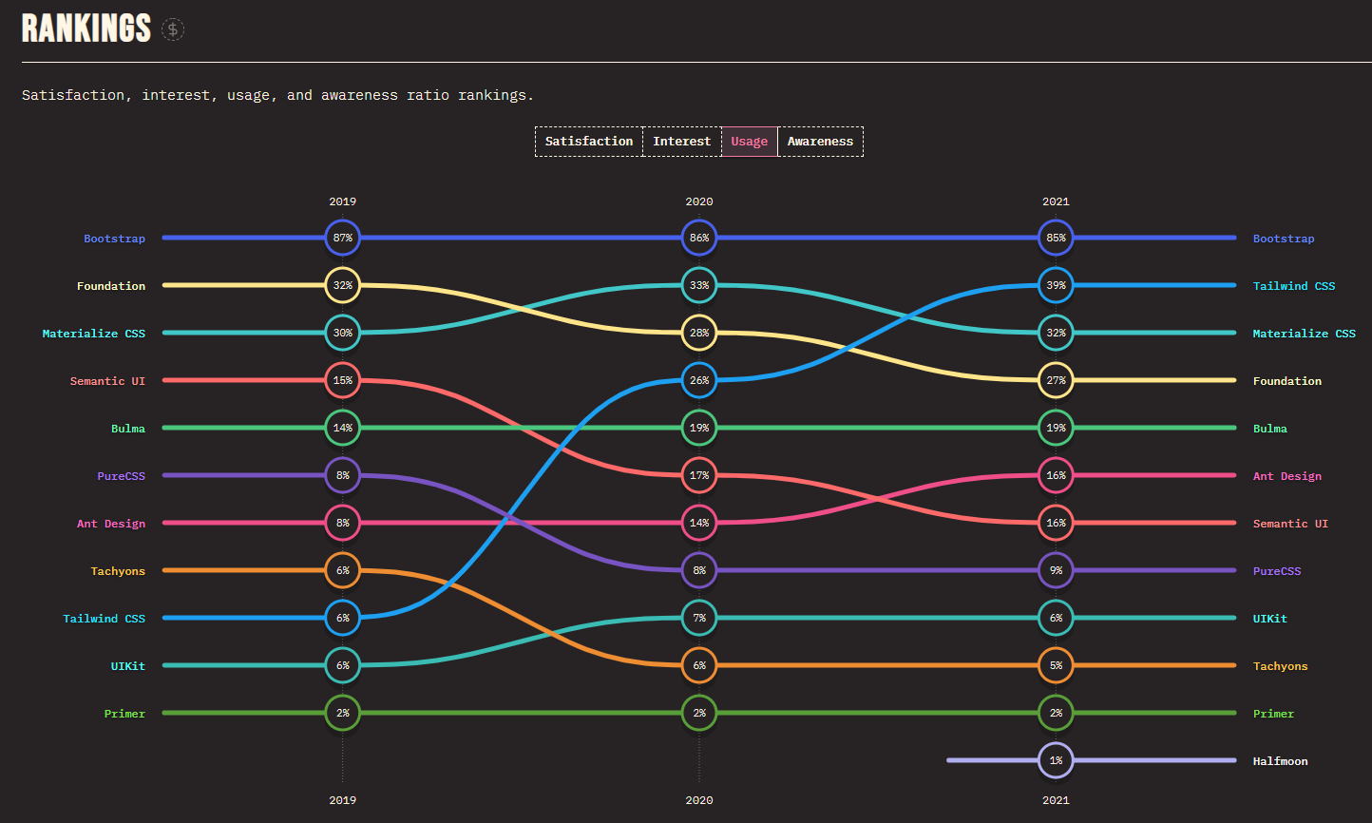

Figure 4: Ranking using CSS Frameworks[11]

### JavaScript

Like CSS Framework, JS Framework is a pre-written code, it contains compilers, interpreters, libraries, etc. Users only need to understand the operation rules and call out the functions for easy use.

The benefit of using JS Framework is increased overall efficiency. JS Framework gives your project a more detailed structure, ready to provide common programming solutions. JS Framework has many different types of libraries and attracts a lot of users and developers like Angular, React, Vue, ...

#### React

React [8] consists of 2 prominent parts: ReactJS and React Native.

* ReactJS is used to build websites on computer environments: Windows, MacOS, ...
* React Native is used to build websites on mobile environments on many operating systems: Android, iOS, ...

Both technologies contribute to bring users the latest functions and their convenience. And React is also rated as one of the most used frameworks, because it always has a solid community that always supports users and React's usage will not cause difficulties for users. So, what is React? What features does it have? What are its benefits to users? These questions will be analyzed and answered below to help readers have a good view and can choose this framework to apply to their web projects.

##### What is React?

React[12] [25] is the most popular JavaScript library for building user interfaces (UIs). It gives excellent response speed to user input using a new method of rendering web pages.

React components are developed by Facebook. It was launched as an open-source JavaScript engine in 2013. It is now ahead of major competitors like Angular and Bootstrap, the two best-selling JS libraries of the time.

React is also one of the most used and downloaded JS libraries, as well as one of the programming libraries that are requested by many companies to recruit in some countries with high salaries and are also widely used. widely because of the features it offers.

##### Feature of React

React's features are many, but here are a few outstanding features of React those users can use or here are outstanding features in React.

* JSX

JSX is a language that allows writing HTML code in JavaScript. Features: Faster: Faster. JSX performs optimization while compiling to JavaScript code. These codes give much faster execution time than an equivalent code written directly in JavaScript. Safer: more secure. In contrast to JavaScript, JSX is statically-typed, meaning it is compiled before runtime, just like Java and C++. So, errors will be detected during compilation. In addition, it also provides very good debug when compiling. Easier: Easier. Legacy JSX is based on JavaScript, so it's very easy for JavaScript’s programmers to use.

* Components

React is built around components, not templates like other frameworks. In React, we build websites using small components. We can reuse a component in many places, with different states or properties, in a component that can contain other components. Each component in React has its own, mutable state, and React will perform component updates based on state changes. Everything React is a component. They help maintain code when working on large projects. A simple react component just needs a render method. There are many other methods available, but render is the dominant method.

* Virtual DOM

Virtual DOM technology helps to increase the performance of the application. The fact that only the root node has state and when it changes, it will completely restructure, which means that the DOM tree will also have to change part of it, which will affect processing speed. React JS uses Virtual DOM (virtual DOM) to improve this problem. Virtual DOM is a JavaScript object, each object contains all the information needed to create a DOM, when the data changes it will calculate the change. switch between the object and the real tree, which optimizes the re-rendering of the real DOM tree.

* React Native

React Native is a user interface framework built for creating mobile apps. With React Native, users can create applications on operating systems such as Android, iOS, and Windows. Similar to ReactJS, React Native is based on components that, when developed, create complete user interfaces. There are many applications using React Native on mobile devices such as Skype, Instagram, Facebook, ...

* Redux

Redux is a predictable state management tool for JS applications. It helps you write applications that work consistently, run in different environments, and are easy to test. Therefore, Redux is often used in combination with React.

* Backend Framework Integration

React on Rails integrates Rails with Facebook's React front-end framework. It provides Server rendering, commonly used for SEO crawler indexing and UX performance, and is not provided by rails/webpacker.

##### Distinguish ReactJS with React Native

ReactJS:

* Original: ReactJS is a JavaScript library created by Facebook to solve performance and compatibility issues for web applications. ReactJS was born in 2011.
* Development Tools: ReactJS, developers need to choose the best and most necessary modules before starting a project.
* HTML: ReactJS is usually rendered using mainly components that contain specific components or HTML tags

React Native:

* Original: React Native is a framework used to develop applications for mobile (specifically Android and IOS). Released 4 years after ReactJS.
* Development Tools: React Native provides everything needed. You can instantly write an app in React Native with just one command line.
* HTML: React Native does not use HTML to display the application interface. Instead, React Native provides components that do the same thing, and most of them can be transformed into their HTML equivalents.

##### Tools for React

As we all know, React is a JavaScript library that helps in UI design. But not everyone knows all the tools that will be introduced in this article, which will help users have a much more enjoyable React experience.

* React-proto[13]

React-proto is a prototyping tool for programmers and designers. This is a desktop software, so users need to download and install it before using it. This application allows users to declare props and their types, view components in a tree, add backgrounds, define whether they are stateful or stateless, what the parent component is, zoom in/out, export prototypes to a project new or existing project…

* React Developers Tools

React developer tools is a utility that allows testing the React Component hierarchy in Chrome and Firefox developer tools.

* CodeSandbox[14]

This is one of the best tools out there that makes react faster than the blink of an eye.

CodeSandbox is an online editor that allows users to create web applications from prototype to deployment, all on a single website.

Initially CodeSanbox only supported React in earlier stages. But now they have extended to additional starter templates for libraries like Vue and Angular. It also supports starting your next react web project by creating projects with popular static site generators like gatsby or nextjs.

There is much to be said about CodeSandbox, such as its activeness. This tool is nothing more than a powerful VSCode editor.

##### Advantage of React

React's [17] superior features bring users many advantages to use, besides there are a few disadvantages that developers are trying to overcome in upcoming updates.

* Reuse

Components can be reused, eliminating the need for programmers to rebuild from scratch, and optimizing usage time.

* Big community

React has a large community that helps programmers get help, so if users encounter difficulties in the process of using React, the community is the place that can provide maximum support for users and solve them.

* Easy to use

React works based on a combination of HTML and JavaScript, so it is quite simple and easy to use for those who have mastered JavaScript knowledge. Besides, you can add code to render function easily without string concatenation. With a large community, it is not difficult to learn how to use this library, as the documentation and information related to React are very popular and are widely taught at universities or on the internet.

* Simplicity

React uses JSX files, which makes the application simpler and easier to understand. If users know how to use JSX files, then the source code will be managed clearly and will be easy for readers to understand, and others can learn from that source code.

* SEO Friendly

This can be said to be a special feature that only React has, thanks to its support and the browser also returns web pages on the Server and Virtual DOM when you run ReactJS. This is why it supports and fulfills every need when you need a user-friendly website.

* Facebook

Because React is made by great Facebook developers. And React is also source code, so React will be supported and built by many developers behind it. Therefore, React will be widely used by the community because of the support from the back-end developers.

##### Disadvantage of React

* Continuous updates

React is one of the frameworks that evolve very rapidly and continuously. Since React has always been built and supported by many great developers, there will always be a lot of changes and updates. Each update will have a change in programming, so it will be difficult for developers to access and update continuously. Because they always have to change their way of working when using React.

* Poor document

Because React updates constantly. Therefore, supporting documents and information cannot be updated in a timely manner. Since documents need to be thoroughly checked and correct, it also takes time to create new documents that are responsive to users.

* Unaccustomed to using JSX

React uses JSX. Since this is built-in syntax, not all developers can know how to use it. The fix for anyone who doesn't want to use JSX is to be able to use basic JavaScript for React, but if you do, your source code will become verbose.

* React only serves the View layer

React is just a View Library, not an MVC framework like other frameworks. This is just a Facebook library to help render the view. So, React will not have a Model and Controller part, but must combine with other libraries. React also won't have 2-way binding or Ajax.

##### Conclusion about React

After analyzing React, users can understand the features, benefits and disadvantages of React. React has contributed a lot to the community in particular and Web development in general. Users can create a sample project through the above guide to have a more objective view of React. React is considered open-source JavaScript in the future, Facebook has committed to improving and improving the efficiency of this tool, helping it to surpass all other support tools available. Users can expect a React in the future with a series of new renders, many unique JSX syntaxes, no need to use keys, and the ability to handle errors quickly and efficiently.

React is the number one UI building solution today. Learning what React is gives you the opportunity to make the right choice in developing future websites and apps. If users choose React as the main framework for development, they will surely enjoy the features it brings and have a strong belief in this framework.

#### Angular

Angular is a very powerful JavaScript Framework and there are many versions that have been released. Developers often use Angular to build Single Page Application (SPA) projects.

Angular has two versions: AngularJS and Angular.

Angular works based on extended HTML attributes (attributes according to Angular's rules). This completely free, open-source framework is loved and used by thousands of developers around the world. So, users need to grasp the basic rules and features to be able to use this framework.

But it is still trusted and used by the majority of programmers. What features does it have that many developers trust, what benefits does it bring to developers? A lot of questions are raised for the community as more and more people are still using Angular as their main framework. Information about Angular will be answered below.

##### What is Angular?

AngularJS[15] [16][11] is one of the first frameworks born a long time ago, built and developed by the Google company, born in 2010. The birth of AngularJS2 has caused controversy because the structure and language of AngularJS2 is completely different. With the first version, maybe those who have learned AngularJS1 will have to learn from the beginning, but in version 3,4,5,6, they will be gentler in using and learning. AngularJS has another language called TypeScript, a language like JavaScript but will be more structurally strict.

The popularity of AngularJS is not appreciated in terms of usage, but they have a strong enough community to be able to support and answer.

Angular is also focusing on stability and robustness through innovation and a perfect framework for enterprise application development.

##### Feature of Angular

* MVC

Angular provides developers to write applications in the MVC (Model-View-Controller) model. In Angular, when using the MVC pattern, developers can explicitly write other machine-side applications.

* Free

Angular is a free and open-source code. Since it was released in 2010, there are already many long-time developers around the world using Angular, so users will also get answers from the community.

* Multi-platform

Angular is cross-browser compatible, so Angular can execute JavaScript code to work well on different browsers.

* Binding

Angular has a way to code Binding (connection between html and data) data in a 2-way fashion, meaning that when the html input changes, the JavaScript variable will immediately receive the return value and vice versa, the value in js changes. immediately the html screen changes. To bind a string to the html screen is very simple using 2 curly braces {{NameVariable}}

* Component

Components are a block of code in an Angular app. It is a combination of html template and embedded with TypeScript (or JavaScript) code. Components are independent of each other and independent of the system. It can be installed or removed from the system easily. A component can be understood as a control on the display screen, including the html interface and the event handling logic code associated with that control. A component can also be as large as an entire screen containing multiple controls or a group of multiple screens. That is, a component can also contain and call many other components

* Service

It is considered a singleton object that can be instantiated only once unique to each application and it provides available data options such as: ($http, $sce, $rootElement, $controller, $document, $httpBackend, $compile, $parse, $rootScope ....)

* Deep link

Deep linking, which allows you to encode the state of your application in URLs so that it can be bookmarked by search engines. Applications can be restored from the URL with the same state.

##### Advantage of Angular

* Increasing productivity

Angular has improved developers' performance by combining with Typescript, handling JavaScript limitations like data checking, ... helping developers understand their functionality as it does.

* Community and Documentation

Supported by Google and the Angular community, information and questions are posed and answered on the community sites. So, users will not be surprised when using. With the amount of documentation and libraries being constantly updated, Angular helps users save time coding and integrate more functions.

* Cross-browser compatibility

AngularJS is suitable for different browsers. AngularJS applications can run on most web browsers, Angular also supports mobile platforms including Android and IOs.

* Reused Component

Components can be reused more easily

##### Disadvantage of Angular

* Unsafe

Because it is developed from JavaScript, Angular JS should have security and server-side validation that will make the application more secure.

##### Conclusion about Angular

Angular is a language that has been around for a long time, but in order to maintain the number of users until now, the developers of Angular have had to work hard to release updates to fix the errors that many people have complained. But the features it brings to users are undeniably, making it easier for users to use them. Today, there are still quite a few companies that are still recruiting developers for this Angular framework with a salary comparable to React, so users can use the framework as a main framework to develop their web applications.

#### Vue

VueJS [8] is a fairly well-known framework, it is built according to the Step-by-Step model, so it is quite convenient and easy to use and develop websites on the Front-end platform. Vue has good support for users, because it is also very easy to learn and build effective websites, especially it will build your website in the form of SPA (Single Page Application), so it improves performance quite well. So, what functions VueJS has, and what are its benefits to users, we will analyze below.

##### What is VueJS?

VueJS[16], as one of the frameworks developed by former Google employees, is one of the flexible frameworks that can handle many situations, which is the choice of many developers and programmers.

VueJS is a combination of many frameworks, and when building products, VueJS is very convenient when combined with other frameworks for development.

In many ways, it has become the middle way between React and Angular and provides a pleasant alternative to both Angular and React.

##### Feature of VueJS

* Data Binding

Data Binding is almost always present in every framework. In VueJS, data binding helps to manipulate or assign values in HTML attributes

* Components

Components in VueJS are one of the important features that help Vue generate elements, which can be used in HTML, similar to React.

* Animation

VueJS can add third-party animation libraries that add interactivity to the interface, so the integral transition element needs to be wrapped around the element to get the transition effect.

* Templates

VueJS provides users with many HTML-based templates. Vue compiles templates into virtual DOM functions, so the templates are all based on HTML templates bound to the DOM.

* Lightweight

VueJS scripts are very lightweight and perform quite fast.

##### Advantage of VueJS

* Easy to learn

Vue does not require too much in-depth knowledge, so it will be easier for beginners to get started than other frameworks.

* Virtual DOM

Similar to React, Vue.js uses the Virtual Document Object Model (DOM) to render views.

* Compatibility between frameworks

Vue's compatibility is highly appreciated by programmers. Because it allows you to write templates in HTML or JS. Vue's framework structure is quite similar to React and Angular, so you will also easily switch from React or Angular to Vue. Vue allows developers to add Vue CDN before starting the product because Vue CDN has a lot of libraries and components so when using it, there is no setup of nodes and npm.

* User Interface

Vue is a framework that has always focused on working with UI. This is possible because it only requires HTML, CSS and JS to work with it and doesn't rely on too much Vue-specific stuff.

##### Disadvantage of VueJS

* Language

Because Vue is a new framework, the community does not have many members, so when users have difficulties, the community will be less interactive and limited. Because Vue was developed by Chinese-Americans, Vue has a large number of non-English-speaking users

* Plugins.

Plugins available on Vue can be used with other frameworks that are not well-supported. Since Vue has only recently evolved, if you are a new user, it is recommended to update regularly.

##### Conclusion about Vue

As you can see, there are many software technologies that make applications faster, more user-friendly, known as a framework built on top of the Javascript client-side programming language. - VueJS is becoming more and more known to become one of the new software technologies for web development today. So, through the information analyzed above, it can be seen that VueJS can become a popular framework in the future, with some language limitations of the community, but if many people use it, limitations will disappear over time. VueJS and its developers are working hard every day to help this framework have a user base that will surpass some frameworks like React.

#### Svelte

When talking about JavaScript frameworks or libraries, there must be 3 popular names that will be mentioned by everyone: React, Vue and Angular, it is also true that these frameworks / libraries are at the top, behind them is a whole huge community to support. So, what is Svelte framework, which has recently been evaluated by many users as a potential framework for development?

##### What is Svelte

Svelte[17], also known as SvelteJS, is a front-end JavaScript framework developed by Rich Harris to build user interfaces quickly and easily. In essence, Svelte is a compiler that compiles the specific syntaxes that you write from Svelte into pure HTML, JS, and CSS at build time, increasing performance by reducing processing steps on the client side.

React or Vue uses virtual DOM, allowing programmers to write declarative state-driven code, which makes the browser have to do extra work to convert declared structures to DOM operations, thereby wasting frames as well. like extra work for garbage collector.

Instead, Svelte is like a compiler, it "runs at build time", converting the user's component directly into a JavaScript code that directly updates on the DOM. Svelte is rated as the top choice to build an application with great performance!

##### Feature of Svelte

* Code less

Making software in general, and writing code in particular, have more or less risks of errors and bugs. Having to write a lot of code, you have to spend a lot of time > your codebase becomes big, maintaining, handling bugs takes a long time > you want to develop more cool features, optimize performance, learn more knowledge or you want to spend time with friends, family, entertainment... you don't have time. Therefore, the less coding, which means that your product will have fewer bugs, or at least you can easily find errors to handle, you will have more time for activities other than just "fixing bugs".

* Don't use Virtual DOM

If you have been using today's popular libraries/frameworks like React or Vue, you will probably be familiar with the concept of "Virtual DOM" (virtual DOM) as well as often heard of "Insanely Fast Virtual DOM". From the perspective of Rich Harris, the creator of Svelte, using Virtual DOM to process the user interface is not quite as fast as we think. Therefore, Svelte does not use Virtual DOM but is purely a compiler that compiles your code into pure JS language, zero dependency.

* True Reactive

If users feel bored, unable to understand the complex state management mechanisms in JavaScript libraries/frameworks. Svelte is the choice for you, Svelte takes the "reactivity" mechanism in JavaScript to a new level, extremely simple and easy to implement.

##### Advantage of Svelte

* Accessible

Easy to access if anyone has worked with VueJS or ReactJS because Svelte also has similar concepts.

* Simple

It is one of the simplest frameworks to use, ideal for beginners.

* Brief

Because this is a framework built on its own structure and drawn from predecessor frameworks like React and Vue. So, the source code of this framework also becomes short and easy to use.

##### Disadvantage of Svelte

* The community does not use much

Svelte has only recently launched, so it is not yet accessible to many new developers and users, and it also takes time for them to become accessible.

* Not many 3rd libraries yet

This framework is quite new and there are many bugs in the implementation process, so Svelte cannot support it (package, component...).

##### Conclusion of Svelte

Svelte is a good choice if the user is intending to build a small project (component or simple web app). For larger projects, Svelte can still be met, but users should consider it because Svelte is still quite new, unstable and does not have much support, so large libraries/frameworks are still a safer choice.

#### Other JS Frameworks

There are many other versions of JS Framework that have been released a lot such as: Preact, Ember, Solid, ... With each released Framework, each with its own features and benefits, the JS Frameworks are built. with the aim of bringing the most convenience to users, helping them to build web applications quickly and with as few difficulties and limitations as possible. Nowadays, many JS Frameworks are being researched, maybe in the future, more JS Frameworks will be released and provide users and developers with simple features and will have enhanced functionality. The performance of web pages brings closure to Web Development.

These are the statistics of the most used frameworks as of 2021.

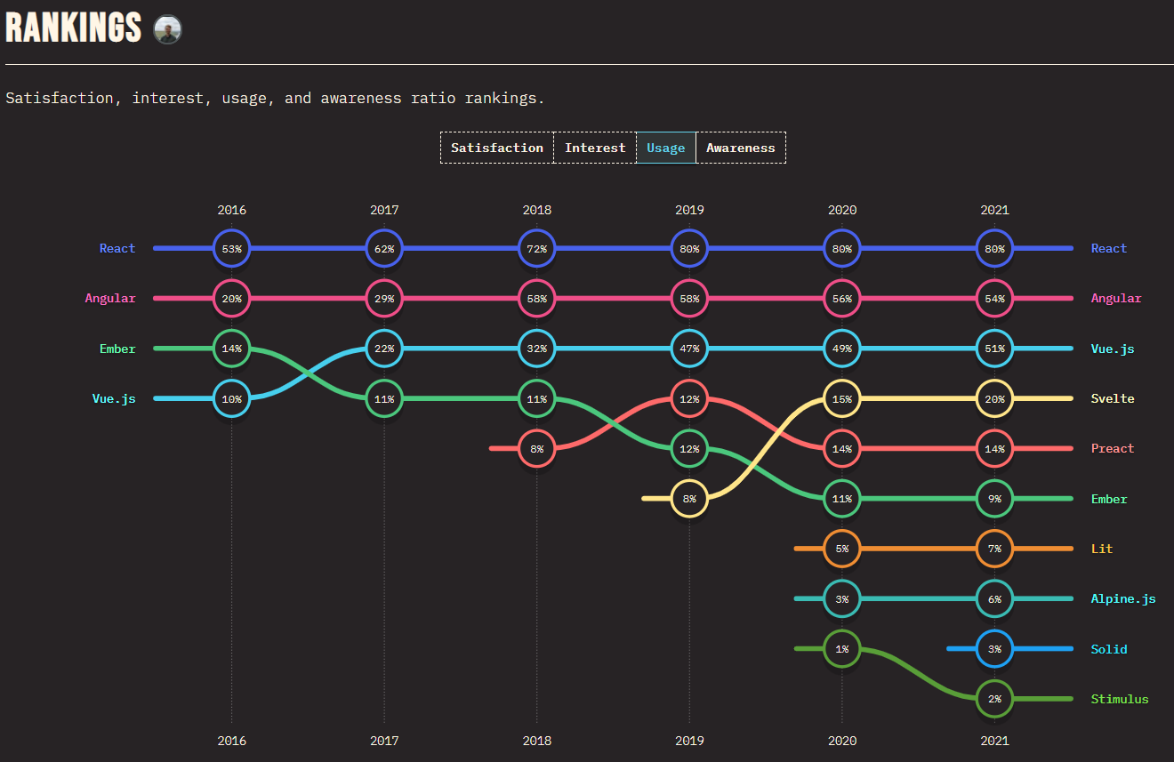

Figure 5: Ranking using JS Frameworks[18]

# WAY OF WEB APPLICATION DEVELOPMENT

## Operating system

Windows [18] is the most popular operating system for computers. Built and developed by Microsoft. This is the operating system that I use to make my project.

## Framework

### HTML5

HTML5 is a programming language developed on the basis of HTML language and most importantly of the World Wide Web (WWW). It is used to design and structure websites, support for maximum multimedia but still make the website friendly to all users and all devices, computer programs, web browsers… Compatibility HTML5's cross-browser compatibility is also an advantage of this language, making the website easy to use and interacting well with users. HTML5 is also mobile-optimized, making it easier and clearer to display on mobile apps.

### ReactJS

ReactJS is an open-source developed by Facebook, launched in 2013, ReactJS is a JavaScript library used to build interactions with components on the website. One of the most outstanding features of ReactJS is that rendering data can not only be done on the Server layer but also below the Client.

ReactJS is a JavaScript library that specializes in helping developers build user interfaces or UIs. In front-end application programming, programmers will usually have to work on two main components: UI and handling user interaction. UI is the collection of components that you see on any application, examples can include: menus, search bar, buttons, cards, etc. Suppose you are programming a website. e-commerce, after the user chooses the product, he likes and clicks the "Add to cart" button, the next thing you have to do is add the selected product to the cart and display the product again that product when the user enters to view.

## SASS

SASS[19] [19][20] is a CSS preprocessor (CSS preprocessor). It helps you to write CSS in the way of a programming language, with a clear and concise structure, easier to develop and maintain the code. In addition, it has a lot of support libraries attached to help you write CSS code easily and simply. There are many types of CSS Preprocessors which include SASS, Stylus or LESS.

Sass stands for Syntactically Awesome Style Sheets, a preprocessor Scripting Language (Preprocessor Scripting Language) program that will be compiled into CSS. That is, I will style it with SASS, and then SASS will render my work into a CSS file.

## Tool and other software

### Redux

Redux[20] is a predictable state management tool for JavaScript applications. It helps you write applications that work consistently, run in different environments (client, server, and native) and are easy to test. Redux was born inspired by the ideas of Elm language and Facebook's Flux architecture. Therefore, Redux is often used in combination with React.

When using a combination of Redux with ReactJS, states are not necessarily upgraded, which makes it easier for users to track changes in actions. Elements also won't use any states or methods to allow child elements to share data between them. When every process has Redux intervention, the application is simplified and easier to maintain.

### Boxicons

Boxicons[21] is a free vector icon collection suitable for user interface design, branding, marketing, icons and net. It comes in four different formats, font files, SVG, CSS, and PNG. The set includes a large number of icons, with variations so that they can be ready for any project that arises.

### Photoshop

Photoshop [21] is an important tool for designers, web developers, graphic artists, photographers, and other content creators. They use Photoshop to retouch the image and cut out or clarify places in the image that are not clear. And web designers use Photoshop to build website interfaces, build banner images and content images in posts.

# CASE STUDY

Before implementing, a project or a certain product, I will design the product using Photoshop, Adobe UI / UX, ... For the product images, logos, I had to use Adobe Photoshop application to adjust the images for the page web.

After performing the download of product images to make data on the page[22]. I have done the graphic design, by adjusting the size, frame, ... to fit the website.

I choose ReactJS as my main framework for designing my website. Because ReactJS is one of the frameworks used and developed by many developers. Besides, ReactJS is also one of the languages ​​preferred by companies and employers to hire and pay a higher salary than other frameworks.

My application is based on a sales website and I will apply some functions and applications to my website, and I will analyze each part that applies to my website.

The case study is based on popular or popular shoe management websites such as FootLocker[23], Nike[24], Adidas[25], ... So, to complete a complete project, some of the features below will be referenced and introduced for project implementation.

Nowadays, there are many e-commerce websites, each with their own unique features and designs or borrowing ideas from the other. So I will analyze some problems and offer solutions in terms of coding and marketing.

## Index Page

First about the index page, because the table of contents page is very important, it will attract a lot of viewers and customers, with some items that will be introduced, introduced, discounted, etc. will be able to help. for customers. Customers are interested in the product, even though customers have many options on other websites, but when they see the attractiveness of the colorful and informative interface, they can still keep them.

Like the website of Bitis (bitis.com.vn), although the design is quite simple, when customers enter, they will be attracted by the image design for the product on the Carousel section. They can see, what items can make them buy immediately.

Besides, when the index page attracts customers, they will be willing to share with friends not only about the product, but also about the website such as a beautiful, simple page design, with many options, …

On the homepage, after viewing the carousel, you can scroll down to see more outstanding products of men, women, ..., discount items according to events such as Independence Day or Black Friday, ...

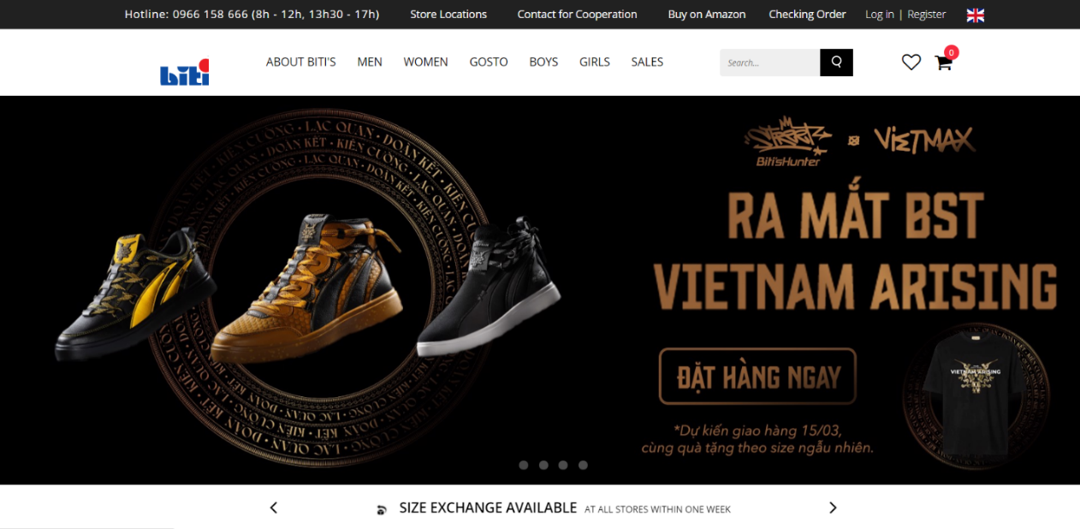Figure 6: Home Page[26]

### Carousel

In the Carousel section, most of the shop websites that I refer to, use designs such as Banners, animations (GIFs), videos or just images and buttons. Few sites, do not use Carousel automatically change banners or images together.

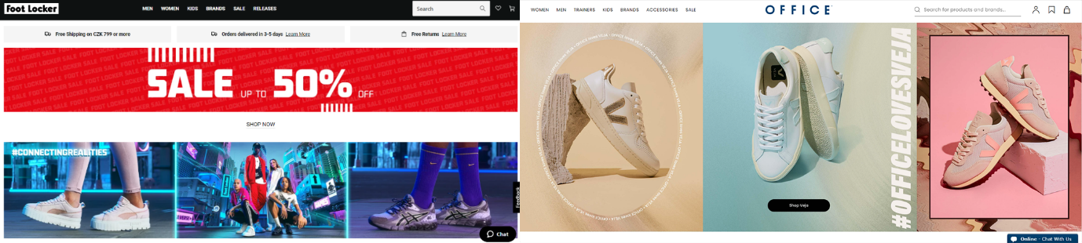

Figure 7: Carousel on Index page

Auto-motion images should be added to attract viewers and give customers more options when choosing the categories, they want. Add left and right buttons so customers may want to see what they will visit, images when posted will fit into the frame, add effects to buttons to make them more interesting row.

In my project, I am going to design a Carousel that can move left and right and it will automatically switch to another page at a specified time. The difference of Carousel in my project from other projects is that Carousel will be designed in with buttons, animated images and have its own background effect, this will make my website more interesting about Picture. The buttons will have an effect when the mouse is pointed at.

### Product

Most websites, add products to the index page, with titles like Bestselling Product, Popular Products, etc. But the admins don't make the products random. or increase interaction for users, in a sales website, it is usually divided into 2 sections:

The bestselling product, in this section, you can leave the product fixed and list those products out, depending on the quantity that the admin wants but for me, it should be 8 products and divided into 2 rows, not necessarily using slider,

Popular products, in this section, you can let the product appear randomly, each time you reload the page, different products will appear, giving users more choices.

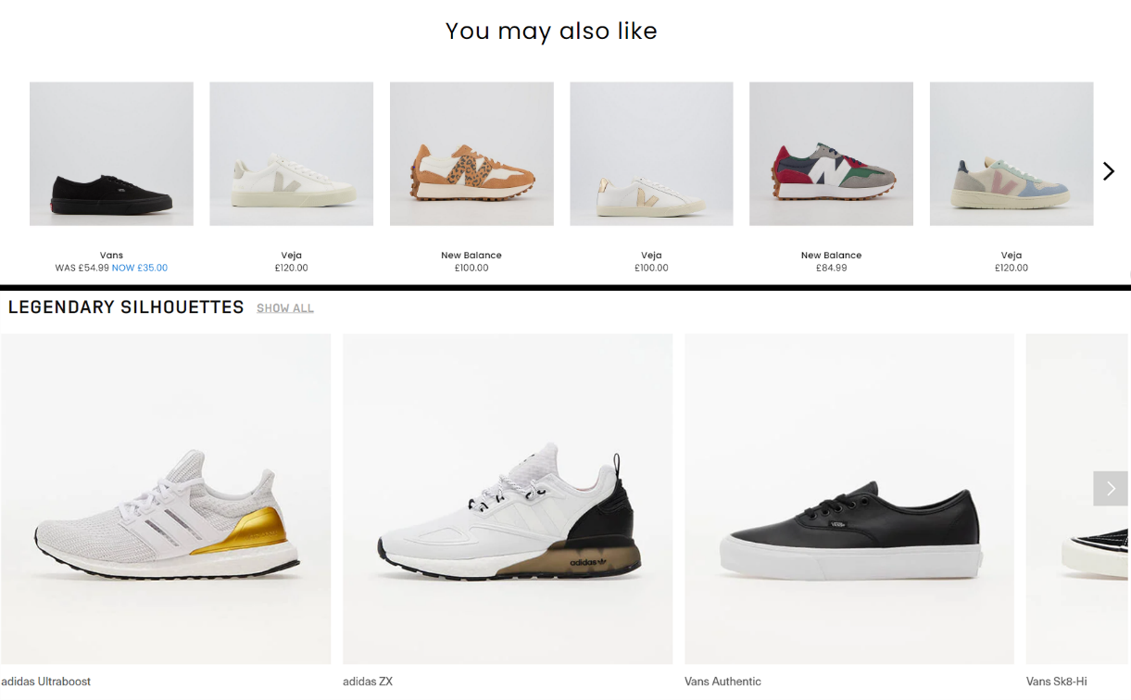

Figure 8: Slider for product in Index page

In the Product section, I will divide it into 2 parts. First is a Popular Product, Second is a Bestselling Product. Most of these products, will appear random products when reloading the page. Because, if a sales site will usually have more than 200 products, and there will be products that appear very rarely, maybe the product has been posted for too long and is above the new products, so I want to Products will appear randomly to help customers find the products they want to buy that have passed for too long, or customers accidentally find the product they want, they will buy immediately.

### Banner

Banner is one of the optional elements for a website, depending on the purpose, but usually there should be banners, because banners are often used to advertise or introduce a certain product or brand to people. Users are curious and will choose those products. Usually websites should use it, as it increases the customer's attraction and attention to the brand and product.



Figure 9: Some banner of product

In the Banner section, like other pages, I will also design a banner between two product items, to increase interaction and attract users. In this section, there will be no problem to solve, but it contributes to increase the attraction for viewers.

## Product Page

On the product page, customers can choose the items they want to buy. Besides selecting items, users can filter out options to choose products according to their wishes. With many filter types such as Size, Brand, Product Type, .... there can be many choices to make.

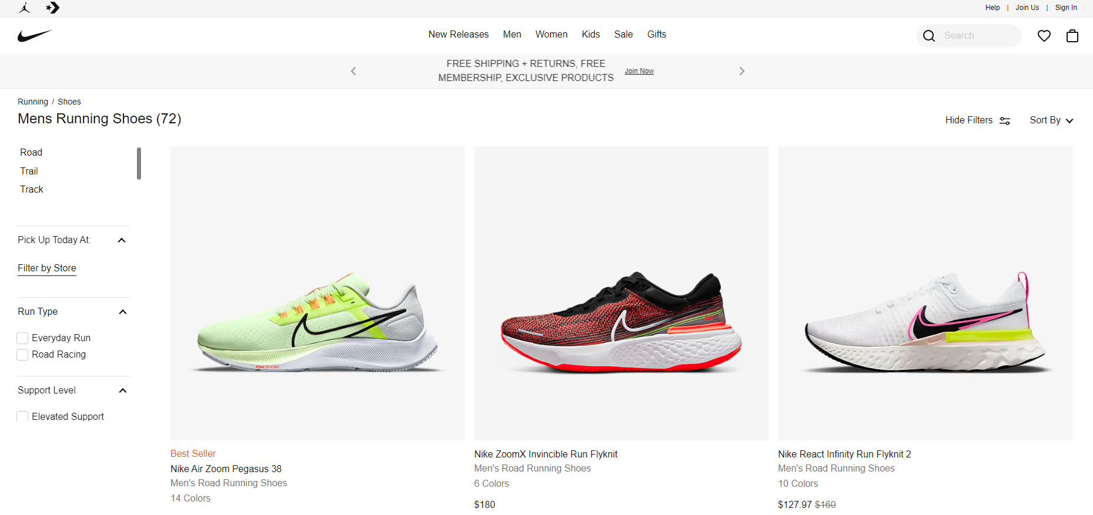

Figure 10: Product Page

In the Product page, there will be many elements to design a website with full functionality and interface for a website. Filter and Product Card are two necessary elements to create a Product Page, besides these two factors, there will be many other functions that can also add to the website to become more convenient and versatile.

### Product Card

Product Card is one of the required components when developing a sales website. Depending on the design of each website, each brand will have different Product Cards, such as being able to zoom, convert images, diversify images, ... these are common effects of a Product Card.

Users can click on an image to view product details, or can click the Buy button to pay directly to the cart.

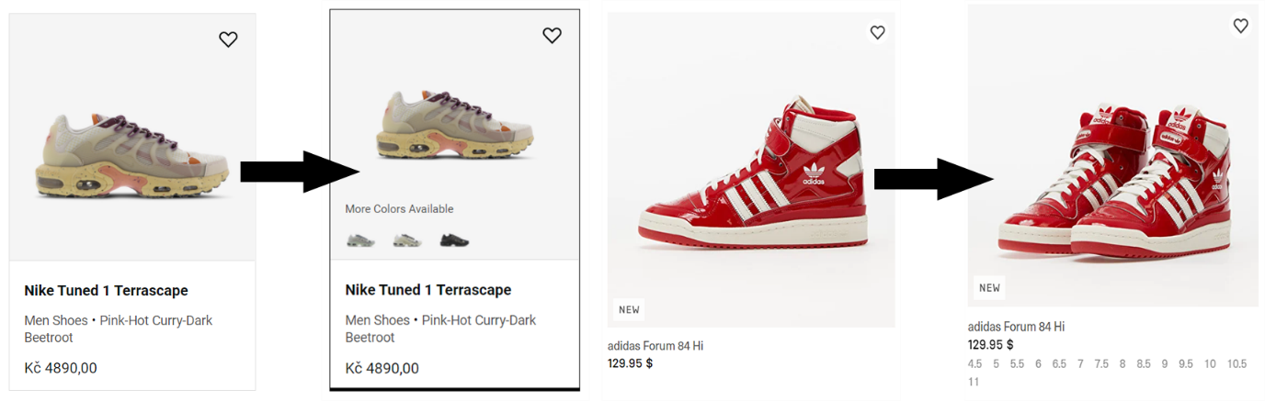

Figure 11: Product Card with effect

In my Product Card, I will design my Product Card, when the mouse pointer on the first image will change to the second image. To do so, I will write functions in the SASS file to develop the effect for the images to transform each other. Basic product information such as name, price, ... along with the Button component.

### Filter

Filter is also an indispensable component in the Product page, because it provides users with the ability to select products according to their interests and search desires. So, Filter is a must-have function, but every filter design is different as each brand wants to provide users with maximum convenience and make it as easy as possible for them to find products.

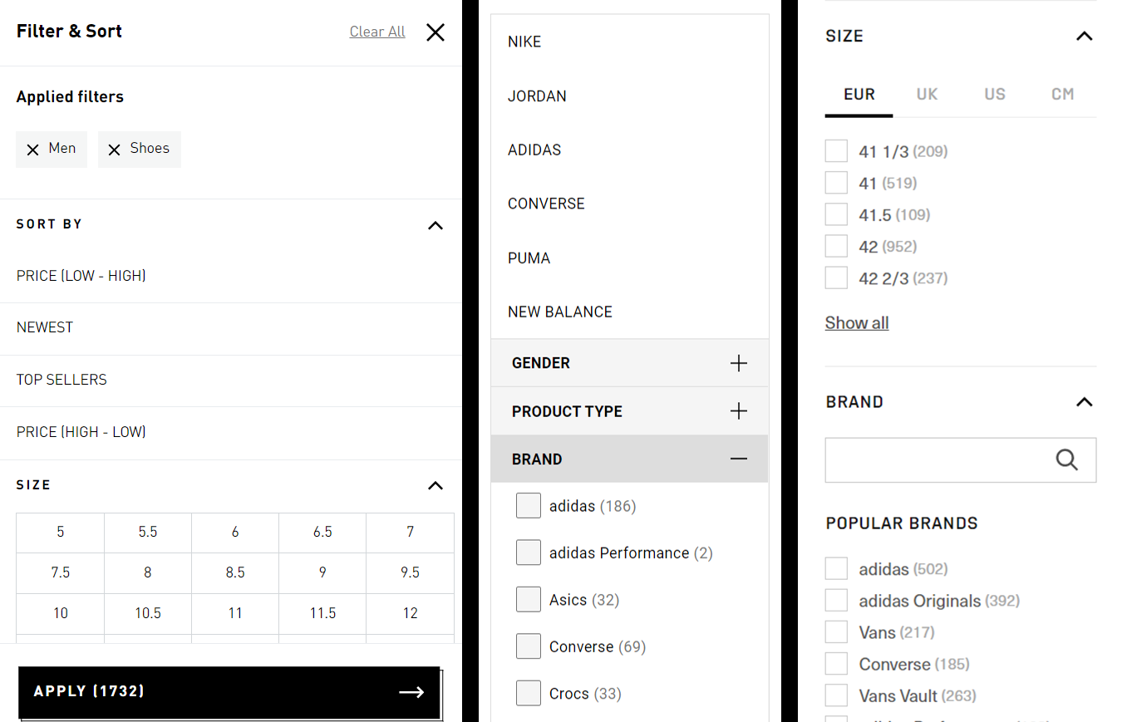

Figure 12: Some design of filter

In the Filter section, there are many different designs. Instead, make the scrollbar horizontal for the Size section, I will tick and add the correct Size list to make it easier for people to choose, because dragging the scroll bar will sometimes be unbalanced by ticking the box.

### Preview Product

In Product Preview, it can be understood as a quick purchase. Quick buy function is the function when the customer wants to buy that product without having to go through the details or visit the Product Detail page. Most of the websites rarely use this function because it is not popular and it does not bring the best quality to use.

So, is there a way without going to the Product Detail page that can view product information and put the product in the cart directly?

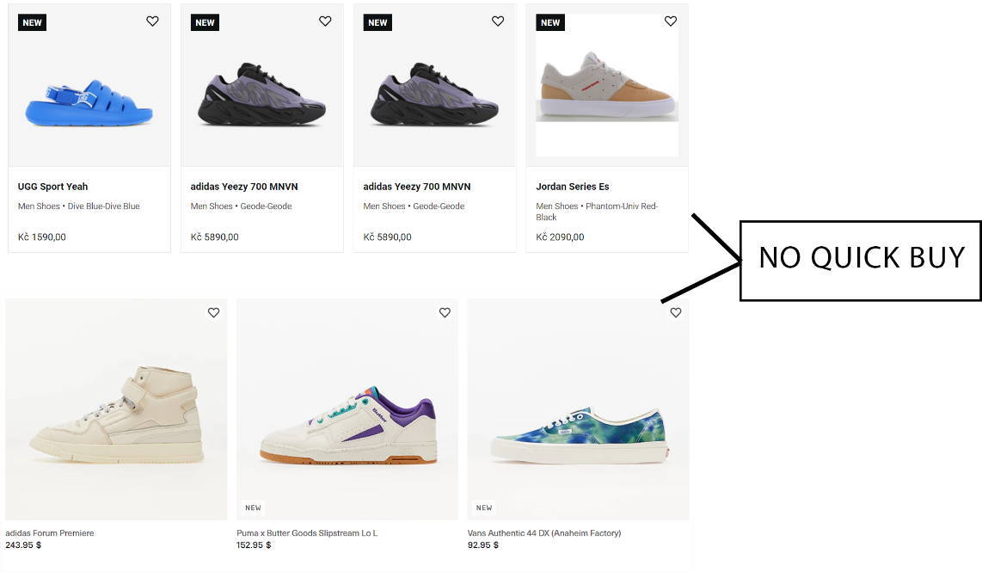

Figure 13: No Quick Buy function on Product Page

In Product Preview, I design another page, this page will not change the link, it won't affect the other page, this page will be on the front of the screen and blur the Product page, but the page functionality will same as the Product Detail page except Related Product, but the template of the page will be neater to help users not take time to access, allowing users to see the full functionality of the Product Detail page without having to access it.

## Product Detail

On product cards, users can point the mouse to see image changes to see details and have more options to consider product perspectives.

In the detailed product section, customers can view product details with many possible contents such as size or color, customers can click the button left or right to see more corner groups about the product they want to buy, along with some add-to-cart features if you want to buy, can help customers choose products without having to go to the store branch to try.

### Information of product

The standard information of a product will usually be the title, price, color, shoe size, quantity, and function buttons. This is usually the standard information of a Product Detail page, each section has its own design and effects. As color, the developer can add another color shoe image or color text, ... For Size, drop down is often used.

Because color using different images gives them a different view of related products but it will take up space for the frame, colored text is not impressive.



Figure 14: Product Detail

So, I want to design a product information page with the functions of color, size, then I will create a circle with full colors, each circle is a color, because not the product is the same color. there are enough colors, so it depends on the products that have that color or not, and the size has the letters S, M, L, XL, ... depending on the shoe has that size or not.

### Image

Image is one of the important elements to give the viewer a look at the product, so depending on the developer's design, the developer can add 2-3 images, depending on the product they want. want to provide, since this is a common function no solution or problem will be given and explained.

### Description of product

Product description, is the part where a developer wants to recommend that product to users, but product description websites each have their own problems. Like the Footshop page, it provides pictures and complete information, but when scrolling up to pay, it becomes time consuming if the information is too long and Footlocker is the same.



Figure 15: Description for product

So, I want to design a description that when scrolling up and down, the user can pay for the product with the checkout button next to it without losing 1-2 seconds.

### Related product

In the related products section, it will be like the Popular Products section on the Index page that will appear random products to help users have more choices instead of fixing a few products, which are already selling well. or very popular, ... So, the solution is always the product will appear randomly when refresh the page or select a new product.

## Cart Page

After they add products to the cart, the basket will count the number of products that have been added to calculate the quantity that the customer has selected.

On the checkout page, this will be the best page because this is a money related page, because when it comes to money, every item will be rated beautifully, customers will see the amount and total product they have selected. But when making the payment, the user will see the size, color, product name, price, ... information provided in full so that the user can check again, and can delete it if not needed.

So, at the payment page, the standards have been provided with all the basic information, so users can use it with peace of mind.

I will also build on the designs and information above for my checkout.

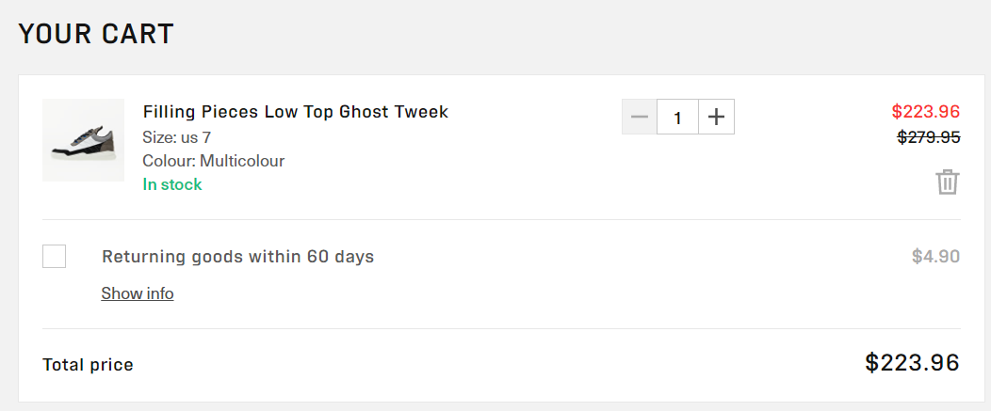

Figure 16: Cart Page

# IMPLEMENTATION

To start building the website, we should use the command line and type the syntax: npx create-react-app [name-project] to create a project using ReactJS framework.

It's up to the user who wants to use CSS or SASS. But I will use SASS.

Users can use Visual Studio Code, to be able to make web building easier, more convenient and faster. I will introduce some main functions of my website. My website, consists of 8 pages, but I will recommend 4 pages, because these are the 4 main and important pages of the website. In all pages, the default 2 components are Header and Footer, because they always appear in the whole page.

In this project, ReactJS can divide a page into many components, users can reuse these components to connect other pages. This is the convenience that React brings to users to avoid wasting time creating new and repeating projects for the project.

According to the process, I have designed from Home page first to Product page, Product Detail page and Cart page. Because these are the four important pages that give the main look and feel of the page. Besides, I designed some more pages like Contact page and Login page.

Most documents that use JSX, declare information directly on the file instead of creating a separate file, so I created a separate data file to use.

## Index page

In the Index page, the function used for this page is the carousel, along with some elements specifically created to combine with the home page.

### Carousel

As in the Case Study, the buttons of the sample web page, always have no effect and are not solid and the carousel doesn't move, so I designed the Carousel with the simplicity of the interface to keep the user from getting stuck and overwhelmed when using.

The user can click left and right to see the effect and turn pages in the carousel.

And the carousel tag is a component created specifically to save space for the home page, easy to use and easy to fix if there is an error. This is the way that to section Carousel is active on home page.

 <Carousel

                data={heroSliderData}

                control={true}

                auto={false}

                timeOut={5000}

            />

Listing 3: Carousel in homepage

In the Carousel component, the functions are set up so that the user can press the left and right buttons to switch pages. And create the function to automatically turn pages in 3-4 seconds. So, while users are viewing products or reading the information in the Carousel, the time setting is automatic, but the user does not need to click to switch pages, making it easier for users to read themselves.

    const data = props.data

    /*set time for carousel*/

    const timeOut = props.timeOut ? props.timeOut : 3000

    const [activeCarousel, setActiveCarousel] = useState(0);

    /*next carousel*/

    const nextCarousel = useCallback(

        () => {

            const index = activeCarousel + 1 === data.length ? 0 : activeCarousel + 1

            setActiveCarousel(index)

        },

        [activeCarousel, data],

    )

    /*previous carousel*/

    const prevCarousel = () => {

        const index = activeCarousel - 1 < 0 ? data.length - 1 : activeCarousel - 1

        setActiveCarousel(index)

    }

    /*set auto turn next carousel*/

    useEffect(() => {

        if (props.auto) {

            const slideAuto = setInterval(() => {

                nextCarousel()

            }, timeOut);

            return () => {

                clearInterval(slideAuto)

            }

        }

    }, [nextCarousel, timeOut, props])

Listing 4: Carousel component

On the Home page, there will be products, posters, and policies. In the product section, the product will appear randomly, each time the page reloads, a different product will appear. During development, I discovered that, if only images and content for the Carousel, it would be too old-fashioned and boring. So, I added a custom image that is always in motion for the background of my animated product image, and it was designed with SCSS.

During the animation design process, I tried a lot of shape motion effects and the shape used was a circle, giving rise to a lot of weird shapes on the page, making the web page funny, so I designed and studying the operation and transformation of the shape, so now the active shape is stable.

            .shape {

                $size: 472px;

                height: $size;

                width: $size;

                position: absolute;

                right: 0;

                top: 50%;

                border-radius: 58% 42% 38% 62% / 42% 55% 45% 58%;

                transform: translate(0, -50%);

                transition: border-radius 12s ease;

                animation: border 10s infinite;

            }

Listing 5: Animation shape background Carousel

Figure 17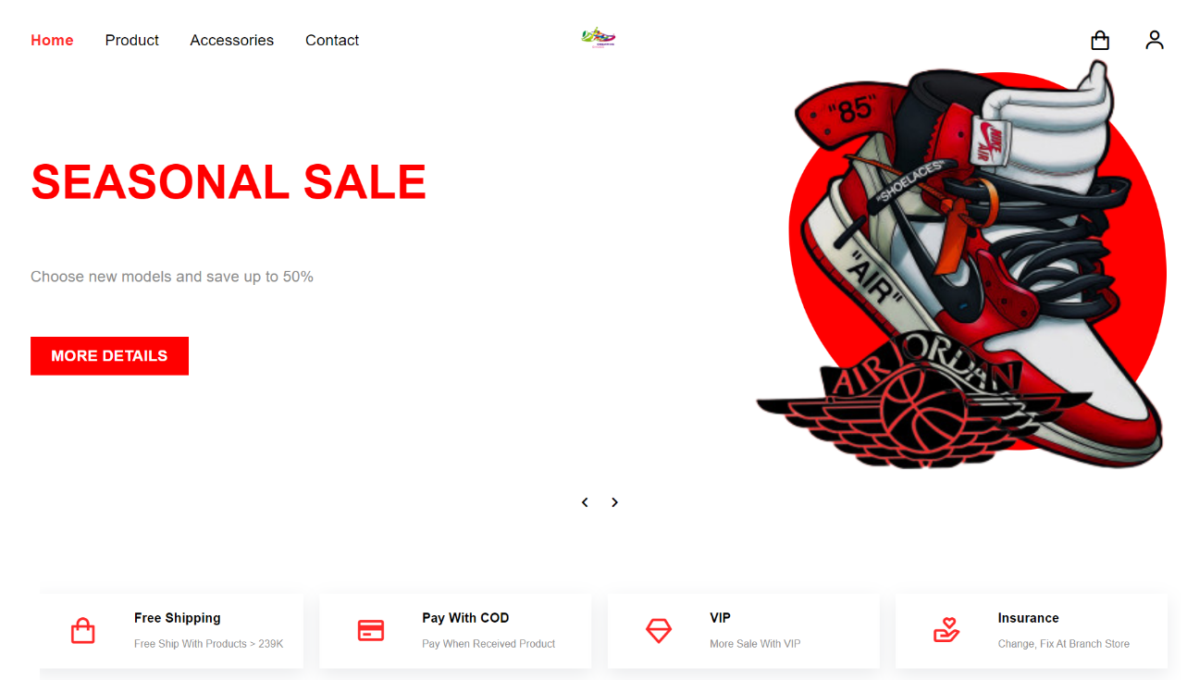: Carousel and Policy card

### Popular Product

In the data file, I have created a separate data in the products.js file which includes functions that get all data, get random data, get data by clicking and add data to cart. In the home page, I used random data so every time the page is reloaded the data will be reordered.

const getProducts = (count) => {

    const max = products.length - count

    const min = 0

    const start = Math.floor(Math.random() * (max - min) + min)

    return products.slice(start, start + count)

}

Listing 6: getProducts

In the home page, just attach the component and the function will work. The interesting thing about ReactJS is that when users are not used to React, they will have a habit of using getdocumentbyid, making themselves wonder why JS and ReactJS are just JS, but why doesn't it work? But in the process of research and reference, developers often use the map function to run the data and display the data to the website.

productData.getProducts(8).map((item, index) => (

<ProductCard

key={index}

img01={item.image01}

img02={item.image02}

name={item.title}

price={Number(item.price)}

slug={item.slug}

/>

Listing 7: Show random products

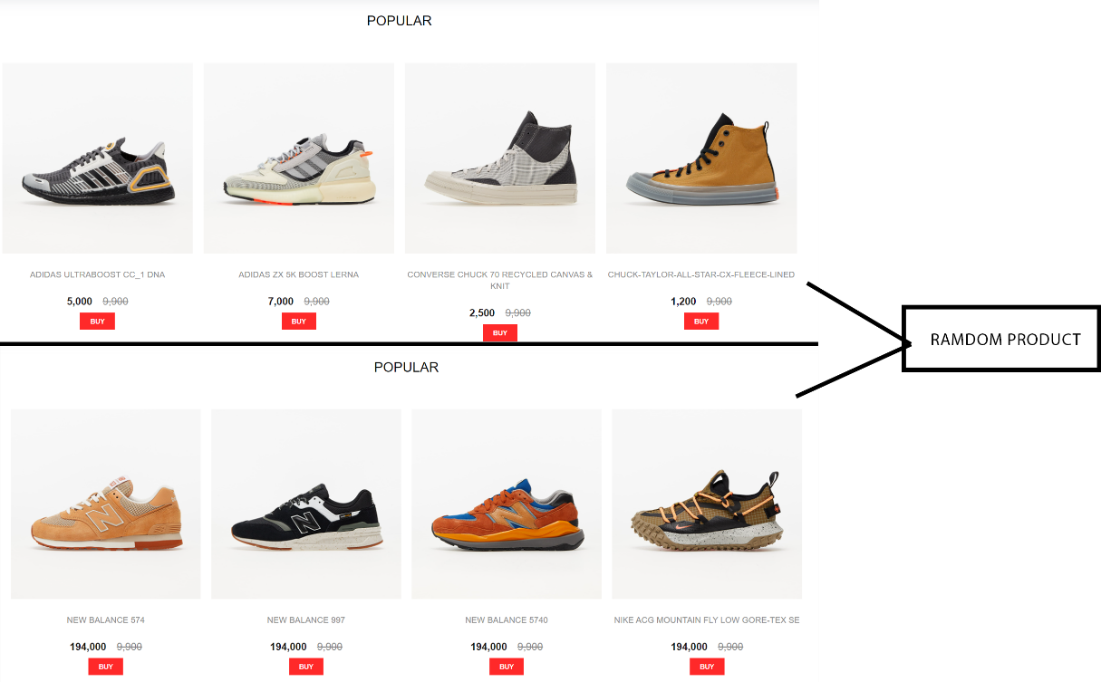

Figure 18: Result of random product

## Product page

On the product page, there will be the main components: filter, product card and product view mini. These are three components designed to serve the convenience of customers, helping customers to see the product they want to get quickly and without any difficulty during use.

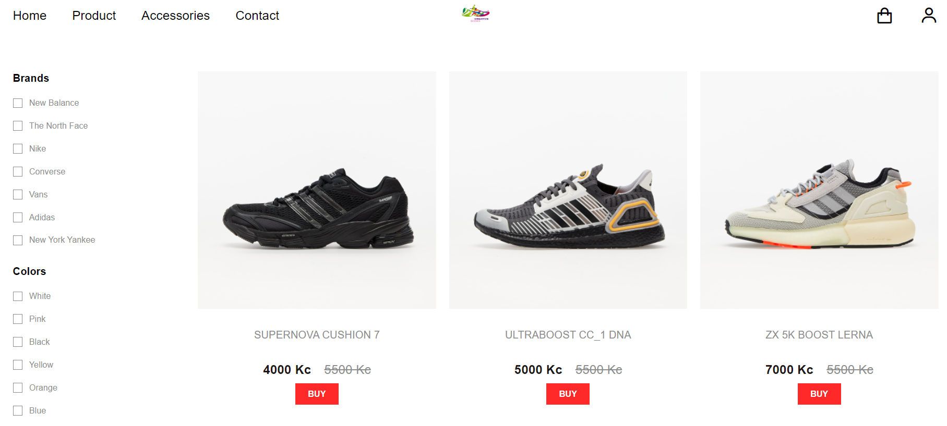

Figure 19: Product Page

### Filter

In the filter, users will be able to select the products they want to choose and prioritize products through the filter. There are 3 types of filters on the product page, which are Brands, Colors, Size, the more filters you choose, the more products customers want to get will appear.

Because in the filter of the sample sites there are always a lot of choices and in this project of mine, I only made a few choices, but the important thing is that when the Color and Size are both selected, the result is the same. whether the return is abbreviated or not. So, after implementation, the results are presented below.

const initFilter = {

        category: [],

        color: [],

        size: []

    }

    const productList = productData.getAllProducts()

    const [products, setProducts] = useState(productList)

    const [filter, setFilter] = useState(initFilter)

    const filterSelect = (type, checked, item) => {

        if (checked) {

            switch(type) {

                case " BRAND ":

                    setFilter({...filter, category: [...filter.category, item.categorySlug]})

                    break

                case "COLOR":

                    setFilter({...filter, color: [...filter.color, item.color]})

                    break

                case "SIZE":

                    setFilter({...filter, size: [...filter.size, item.size]})

                    break

                default:

            }

        } else {

            switch(type) {

                case "BRAND":

                    const newCategory = filter.category.filter(e => e !== item.categorySlug)

                    setFilter({...filter, category: newCategory})

                    break

                case "COLOR":

                    const newColor = filter.color.filter(e => e !== item.color)

                    setFilter({...filter, color: newColor})

                    break

                case "SIZE":

                    const newSize = filter.size.filter(e => e !== item.size)

                    setFilter({...filter, size: newSize})

                    break

                default:

            }

        }

    }

Listing 8: Filter Function

Use a loop to create a selectable filter list, and this is done in HTML.

category.map((item, index) => (

<div key={index} className="catalog__filter__widget__content__item">

<CheckBox label={item.display}

            onChange={(input) => filterSelect("CATEGORY", input.checked, item)}

                      checked={filter.category.includes(item.categorySlug)}/>

      </div>

))

Listing 9: Loop filter to show

### Product Card

In the product page, the products will be displayed using the product card component. In Product Card, just create how one product tag will show on website, after creating tag just add ProductCard component to Product Page, it will show up on web page, but if want to show multiple products then creates a list of products in a JavaScript file and loops in the Product Page to display all the products that have been created in the list.

                    data.map((item, index) => (

                        <ProductCard

                            key={index}

                            img01={item.image01}

                            img02={item.image02}

                            name={item.title}

                            price={Number(item.price)}

                            slug={item.slug}

                        />

                    ))

Listing 10: Loop Product Card to show on Product page

        <div className="product-card">

            <Link to={`/catalog/${props.slug}`}>

                <div className="product-card__image">

                    <img src={props.img01} alt="" />

                    <img src={props.img02} alt="" />

                </div>

                <h3 className="product-card__name">{props.name}</h3>

                <div className="product-card__price">

                    {numberWithCommas(props.price)}

                    <span className="product-card__price__old">

                        <del>{numberWithCommas(9900)}</del>

                    </span>

                </div>

            </Link>

            <div className="product-card__btn">

                <Button

                    size="sm"

                    icon="bx bx-cart"

                    animate={true}

                    onClick={() => dispatch(set(props.slug))}

                >

                    Buy

                </Button>

            </div>

        </div>

Listing 11: Product Card component

const products = [

    {

        title: "ADIDAS SUPERNOVA CUSHION 7",

        price: '4000',

        image01: product_01_img01,

        image02: product_01_img02,

        categorySlug: "adidas",

        colors: ["white", "red", "orange"],

        slug: "ADIDAS-SUPERNOVA-CUSHION-7",

        size: ["s", "m", "l", "xl"],

        description: "Create by Adidas"

    }

]

Listing 12: Create list of products

On Button, when you move the cursor to the Buy Now button, the word Buy Now will become a shopping cart icon. This is the effect applied to create beauty and attract users. In the button, use dispatch to props to determine the state and return the page for that product.

                <Button

                    size="sm"

                    icon="bx bx-cart"

                    animate={true}

                    onClick={() => dispatch(set(props.slug))}

                >

                    Buy

                </Button>

Listing 13: Button on ProductCard component

### Product View Mini (Quick Buy)

In Product View Mini, this can also be seen as a mini page, when users want to use it but do not want to access the Product Detail page but can also view the full functionality of the website. The Product View Mini page allows people to quickly view, pay, and transfer products to the cart.

During the implementation, I think this page is a feature that not all websites have, and this page is also very difficult to implement because to show the page and blur the background, you have to reuse the Product component. View and use only a few elements to display without using Related Product because it will make the page longer. This page is the one that should be used because customers may not always spend a lot of time browsing and selecting products. And this component will be placed in the Layout component.

While doing Quick Buy, when attaching the product view component to the Product View Mini, because in the process of making me, there was a moment that made me laugh all the time, that was when I always attached all the content of the Product View to the Product View. Mini, which causes the page to be inserted and inflated to the web page, which reads the data in a chaotic manner. And when I researched it again, it only took one line, to be able to recover and show the data safely it was the line: **<ProductView product={product}/>** . Only this one line will show up, causing me to waste time researching because I didn't read the code carefully. So, users need to understand what they are doing to be able to fix it, if it is discovered late, it will be like me sitting to find errors and when fixing errors, they will be surprised.

    const productSlug = useSelector((state) => state.productModal.value)

    const dispatch = useDispatch()

    const [product, setProduct] = useState(undefined)

    useEffect(() => {

        setProduct(productData.getProductBySlug(productSlug) ||  productData1.getProductBySlug(productSlug))

    }, [productSlug]);

    return (

        <div className={`product-view__modal ${product === undefined ? '' : 'active'}`}>

            <div className="product-view__modal__content">

                <ProductView product={product}/>

                <div className="product-view__modal__content__close">

                    <Button

                        size="sm"

                        onClick={() => dispatch(remove())}

                    >

                        Close

                    </Button>

                </div>

            </div>

        </div>

    )

Listing 14: Product View Modal components

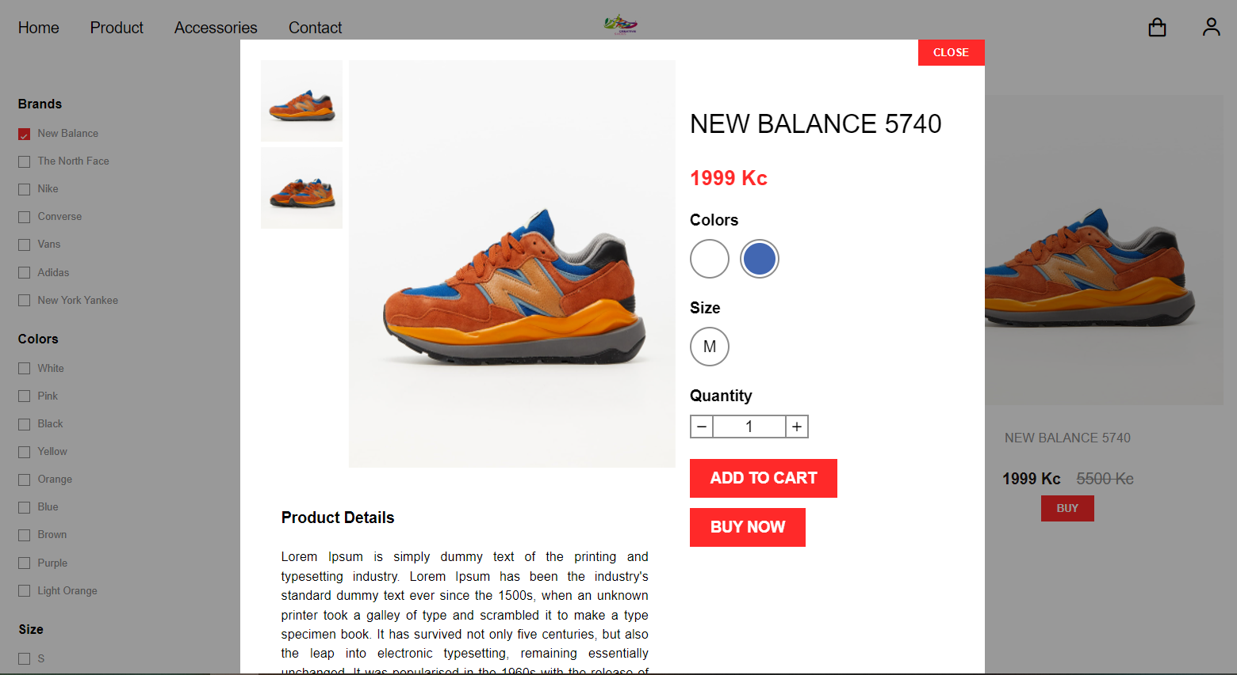

Figure 20: Product View Mini (Quick Buy)

## Detail page

On the Product Detail page, I have set the value to slug, when the user clicks on any product, the link will show the product name in that link without having to initialize hundreds of links if any. hundreds of products. Just attach the value 'slug' in each product and create the link in the Route tag in 1 line: <Route path='/catalog/:slug' component={Product}/>

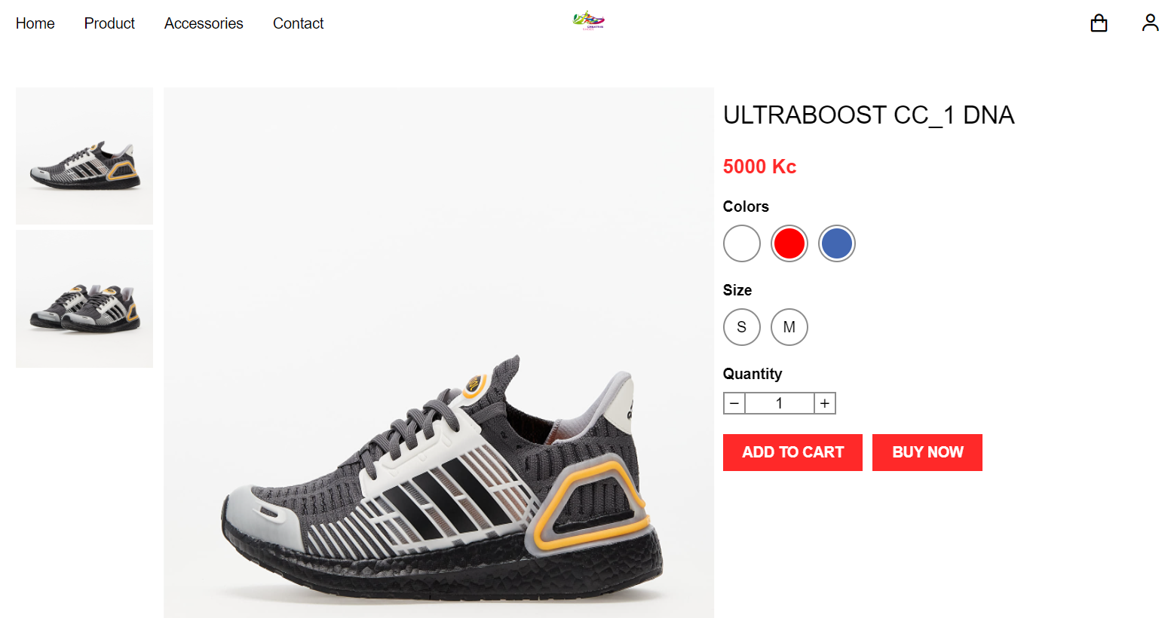

Figure 21: Product Detail

### Description

Users who want to read more can expand by pressing the "See more" button to expand. In my opinion, this is a function that should be applied, because sometimes no one wants to learn and read more in the description, because users are only interested in the price and product image. So "see more" is also a necessary function and I have applied it to my product as a model.

                <div className="product-description__content"

                dangerouslySetInnerHTML={{__html: product.description}}></div>

                <div className="product-description__toggle">

                    <Button size="sm" onClick={() => setDescriptionExpand(!descriptionExpand)}>

                        {

                            descriptionExpand ? 'Collapse' : 'More'

                        }

                    </Button>

                </div>

Listing 15: See More button in ProductView component

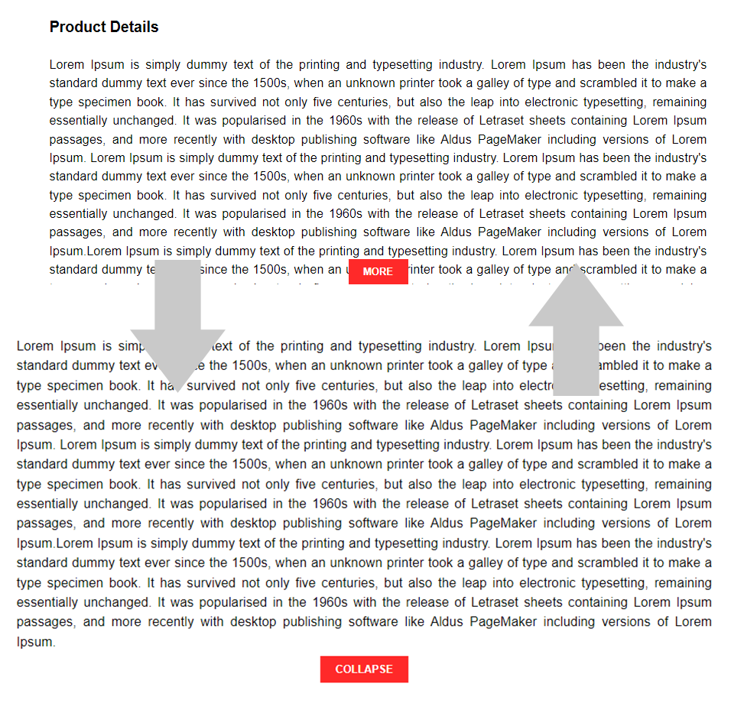

Figure 22: More and Collapse

### Scroll

In product detail, the website will appear product information such as title, color, size, quantity, button ... And when scroll to see information about shoes, the information item will move until the end of the section 'see more'. And the customer will be able to see the related products if the customer no longer wants to buy the current product.

    const product = productData.getProductBySlug(props.match.params.slug)

    const relatedProducts = productData.getProducts(8)

    React.useEffect(() => {

        window.scrollTo(0,0)

    }, [product])

Listing 16: Product for scrolling and related products

Users will have to choose enough color, size and quantity to add products to the cart, if the user does not choose a color or size, warning lines will appear.

    const check = () => {

        if (color === undefined) {

            alert('Please Choose Colors!')

            return false

        }

        if (size === undefined) {

            alert('Please Choose Sizes!')

            return false

        }

        return true

    }

Listing 17: Alert

## Cart page

After the customer chooses to buy the product, the product will be added to the cart. But in order to be able to store it in the cart and be able to update it if you buy a lot or delete products, in React you should use createSlice in Redux. createSlice is a function that deals with everything you need for each slice, an object of reducer functions. This API is the approach to writing Redux logic.

export const cartItemsSlice = createSlice({

    name: 'cartItems',

    initialState,

    reducers: {

        addItem: (state, action) => {

            const newItem = action.payload

            const duplicate = state.value.filter(e => e.slug === newItem.slug && e.color === newItem.color && e.size === newItem.size)

            if (duplicate.length > 0) {

                state.value = state.value.filter(e => e.slug !== newItem.slug || e.color !== newItem.color || e.size !== newItem.size)

                state.value = [...state.value, {

                    id: duplicate[0].id,

                    slug: newItem.slug,

                    color: newItem.color,

                    size: newItem.size,

                    price: newItem.price,

                    quantity: newItem.quantity + duplicate[0].quantity

                }]

            } else {

                state.value = [...state.value, {

                    ...action.payload,

                    id: state.value.length > 0 ? state.value[state.value.length - 1].id + 1 : 1

                }]

            }

            localStorage.setItem('cartItems', JSON.stringify(state.value.sort((a, b) => a.id > b.id ? 1 : (a.id < b.id ? -1 : 0))))

        },

        updateItem: (state, action) => {

            const newItem = action.payload

            const item = state.value.filter(e => e.slug === newItem.slug && e.color === newItem.color && e.size === newItem.size)

            if (item.length > 0) {

                state.value = state.value.filter(e => e.slug !== newItem.slug || e.color !== newItem.color || e.size !== newItem.size)

                state.value = [...state.value, {

                    id: item[0].id,

                    slug: newItem.slug,

                    color: newItem.color,

                    size: newItem.size,

                    price: newItem.price,

                    quantity: newItem.quantity

                }]

            }

            localStorage.setItem('cartItems', JSON.stringify(state.value.sort((a, b) => a.id > b.id ? 1 : (a.id < b.id ? -1 : 0))))

        },

        removeItem: (state, action) => {

            const item = action.payload

            state.value = state.value.filter(e => e.slug !== item.slug || e.color !== item.color || e.size !== item.size)

            localStorage.setItem('cartItems', JSON.stringify(state.value.sort((a, b) => a.id > b.id ? 1 : (a.id < b.id ? -1 : 0))))

        },

    },

})

export const { addItem, removeItem, updateItem } = cartItemsSlice.actions

Listing 18: createSlice for adding, removing and updating in Cart page.

On the Cart Page, besides functions like Add, Update and Remove items. Then there will be equally important functions, which are displaying product information, calculating the total number of items and calculating the total amount of products in the cart and basic buttons such as returning to the home page or continuing to checkout.

    const cartItems = useSelector((state) => state.cartItems.value)

    const [cartProducts, setCartProducts] = useState(productData.getCartItemsInfo(cartItems) || productData1.getCartItemsInfo(cartItems))

    const [totalProducts, setTotalProducts] = useState(0)

    const [totalPrice, setTotalPrice] = useState(0)

    useEffect(() => {

        setCartProducts(productData.getCartItemsInfo(cartItems) || productData1.getCartItemsInfo(cartItems))

        setTotalPrice(cartItems.reduce((total, item) => total + (Number(item.quantity) * Number(item.price)), 0))

        setTotalProducts(cartItems.reduce((total, item) => total + Number(item.quantity), 0))

    }, [cartItems])

Listing 19: Total product and price

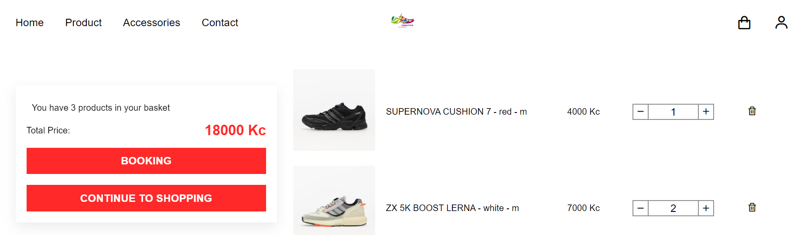

Figure 23: Cart page

## Other Important Components

### Layout

Layout is one of the important components, because this is a component used to manage other components and interfaces, and these usually default components like Header, Footer and just change pages together like Home, Product, ... Components such as Header, Footer have been built and set up before and only need to be attached to the Layout page to activate the interface.

        <BrowserRouter>

            <Route render={props => (

                <div>

                    <Header {...props}/>

                    <div className="container">

                        <div className="main">

                            <Routes/>

                        </div>

                    </div>

                    <Footer/>

                    <ProductViewModal/> //preview product (Quick Buy)

                </div>

            )}/>

        </BrowserRouter>

Listing 20: Layout

### Header

In the Header, the small elements are listed with the role of being able to move from one page to another, and they are the button used to switch pages, that have been enumerated and invoked in the loop.

/* main page*/

const mainNav = [

    {

        display: "Home",

        path: "/"

    },

    {

        display: "Product",

        path: "/catalog"

    },

    {

        display: "Accessories",

        path: "/accessories"

    },

    {

        display: "Contact",

        path: "/contact"

    }

]

Listing 21: Set up list page will display

When the user scrolls the mouse moves up and down, and the main bar will also move. 'Shrink' will be executed when scrolling down. If it returns to the top of the page, 'Shrink' will not execute and stick to the page.

    /*when scroll down, header will go page*/

    useEffect(() => {

        window.addEventListener("scroll", () => {

            if (document.body.scrollTop > 80 || document.documentElement.scrollTop > 80) {

                headerRef.current.classList.add('shrink')

            } else {

                headerRef.current.classList.remove('shrink')

            }

        })

        return () => {

            window.removeEventListener("scroll")

        };

    }, []);

Listing 22: Header will go when scroll down



Figure 24: Header component

### Footer

Footer like Header is used for footer and this is the default page, always appearing on all pages. The important function of this page is to read the list of pages that will be displayed on the web. The remaining functions such as displaying the logo and information about the page, ...



Figure 25: Footer component

### Load Data

In the Product page, there are only 6 products, and when the user scrolls to the bottom of the page, 6 more products will be loaded. This is the Load data function created to save website space and add data when they want to find more products.

const perLoad = 6 // data each load

    const listRef = useRef(null)

    const [data, setData] = useState([])

    const [load, setLoad] = useState(true)

    const [index, setIndex] = useState(0)

    useEffect(() => {

        setData(props.data.slice(0, perLoad))

        setIndex(1)

    }, [props.data])

    useEffect(() => {

        window.addEventListener("scroll", () => {

            if (listRef && listRef.current) {

                if (window.scrollY + window.innerHeight >= listRef.current.clientHeight + listRef.current.offsetTop + 200) {

                    console.log("bottom reach")

                    setLoad(true)

                }

            }

        })

    }, [listRef])

    useEffect(() => {

        const getItems = () => {

            const pages = Math.floor(props.data.length / perLoad)

            const maxIndex = props.data.length % perLoad === 0 ? pages : pages + 1

            if (load && index <= maxIndex) {

                const start = perLoad * index

                const end = start + perLoad

                setData(data.concat(props.data.slice(start, end)))

                setIndex(index + 1)

            }

        }

        getItems()

        setLoad(false)

    }, [load, index, data, props.data])

Listing 23: Load data when scroll down

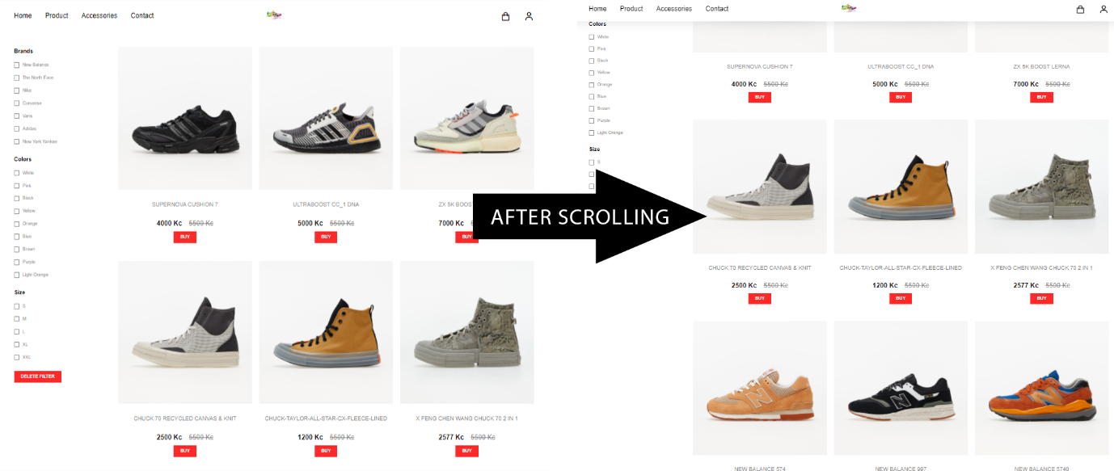

Figure 26: Load data

## Apps for mobile devices

SASS has the ability to support and build both desktop and mobile apps, which is a convenience that SASS offers, just creating value on SASS and deploying it on several sites.

&__filter {

        width: 20%;

        @include tablet {

            width: max-content;

            height: 100vh;

            background-color: $main-bg;

            padding: 1rem;

            position: fixed;

            left: 0;

            top: $header-tablet-height;

            z-index: 100;

            box-shadow: $box-shadow;

            transform: translateX(-100%);

            transition: transform 0.3s ease;

        }

        @include mobile {

            top: $header-mobile-height;

        }

Listing 24: Filter application for mobile devices

This is the test result after doing it on several devices by opening the Dev Tool.

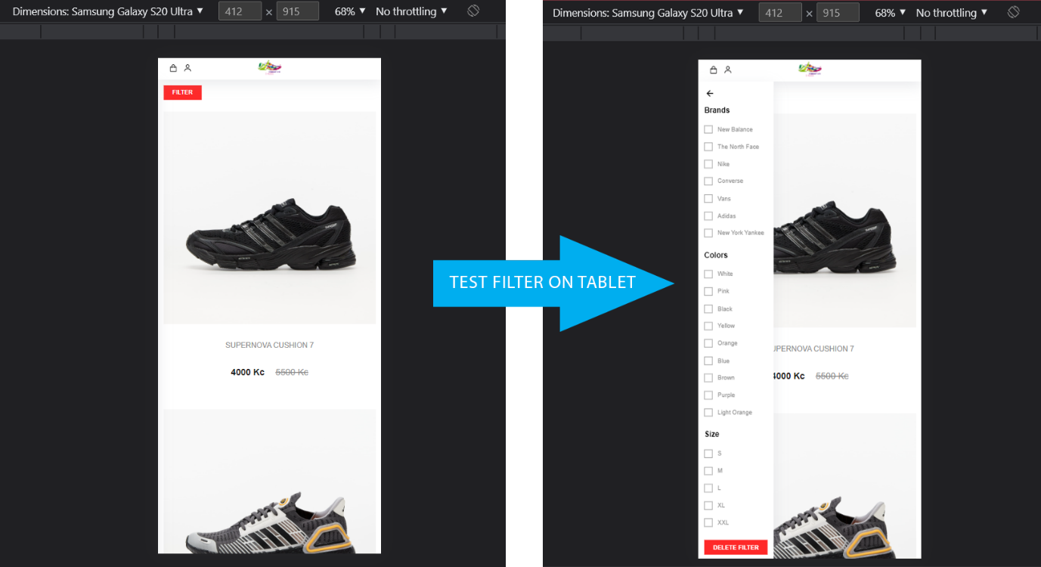

Figure 27: Test filter on mobile devices

# EVALUATION

This is a pretty basic ReactJS project. According to personal assessment, ReactJS is not too difficult to use, but to master it, you have to spend a lot of time and do many projects related to ReactJS, it will help users more.

Normally, to use Back-end with React, users often use NodeJS to connect with each other. For NodeJS applications, a small but powerful framework that is often used is ExpressJS. But for my post, I didn't use the Back-end, which is a big shortcoming of mine.

NodeJS is a software system designed for writing scalable internet applications, especially web servers. The program is written in JavaScript, using event-driven, asynchronous input/output to minimize total resources and maximize scalability. Node.js includes Google's V8 JavaScript engine, libUV, and several other libraries.

The React library is a browser-based frontend library. It is glad to be served by any old webserver – Apache – or any kind of backend – PHP, Rails,..., just like any other frontend library (jQuery,...). Because React and Angular are simply client-side libraries made up of JavaScript files, any old HTTP server – PHP inside Apache, PHP inside Nginx, plain Apache/Nginx, Java Tomcat, Rails inside Passenger, and yes, Node.js – can send them to users.

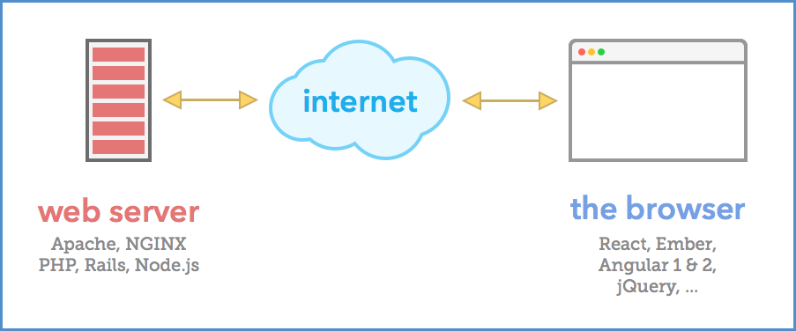

Figure 28: Connect Back-end by NodeJS

ReactJS will have a lot of uses and combinations with different tools and frameworks. Users can use JSX instead of JS, although both can work on ReactJS, but JSX will be a neat file, easy to program, requires thoughtfulness in the project will make the project look good and the code will be easier to understand. JS is usable in React but managing and organizing the source code will be a bit confusing because if you don't know how to organize and it also becomes more confusing it is not shortened.

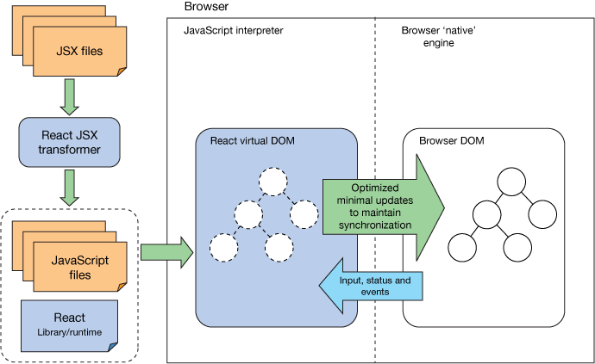

Figure 29: React operations

In the field of technology development, business owners and developers are always looking for the best methods to give their businesses a better competitive edge. And one of the best technologies that can help businesses stay ahead of the competition in creating web applications is ReactJS.

ReactJS allows businesses to create web applications with better UI to enhance user experience. This is also the technology that businesses need to get higher user engagement, click-through rates and conversions. Moreover, businesses using ReactJS are guaranteed to have a better interface than those using other frameworks because ReactJS helps prevent DOM updates for faster applications and better UX delivery.

Facebook and the entire ReactJS team have always strived to demonstrate their commitment to making ReactJS more efficient. This is a prerequisite to overcoming the rapid development of other frameworks like Vue.js.

Although ReactJS has certain limitations, I believe in the future, ReactJS will be able to handle these limitations, because with a large community coming from all over the world, ReactJS will grow more and more, new users will gradually increase and grow quickly.

# CONCLUSION

In this bachelor thesis, I analyzed, designed and implemented the Shoe Shop website. In the analysis section, I read through many research papers on the technique, the market and the differences between the frameworks. During the analysis, I learned and researched how to use React along with some other tools, I designed a basic Shoe Shop website for users to view, refer to and increase the user experience. In terms of interface, I may not have designed the full functionality of a Shoe Shop website, but I believe the important features like add to cart, calculation, filter, ... along with some the design of the colors, the position of the components, ... has been fully designed and can be used by new users. Since I only focus heavily on Front-end, some basic functionality may not be provided. When users refer to this website, they will also understand its usefulness and simplicity so that users can download further development depending on their logic.

Since I focus a lot on React's Front-end, I didn't generate the Back-end data, the product data I generate manually in React. And I learned how to use Redux tool in combination with React and understand the value it brings.

Development of Modern Web Applications is a very interesting topic that helps me to learn a lot about frameworks in JavaScript. Although, there are many shortcomings in this project, I believe, I will improve my work in the future. And the result I bring in this thesis, is to provide users with a view of frameworks so that users can choose the right framework for them. When I choose to React as my main framework for designing a Shoe Shop website, I hope many users will see how I have designed and understand how I have implemented it and consider React as a language. suitable language or not. Web programming is one of the technologies chosen by people and in the future not only React but also many other frameworks will gradually appear and bring users the most convenient things when designing a website.

# References

|  |  |
| --- | --- |
| [1] | Codecademy Team, "HTML5 Features," [Online]. Available: https://www.codecademy.com/article/html5-features. |
| [2] | D. G., "The Differences Between HTML and HTML5," [Online]. Available: https://www.hostinger.com/tutorials/difference-between-html-and-html5. [Accessed 14 April 2022]. |
| [3] | GeeksforGeeks, "Top 10 new features of HTML5," 15 March 2021. [Online]. Available: https://www.geeksforgeeks.org/top-10-new-features-of-html5/. |
| [4] | M. Malhotra, "20 Top Web Development Frameworks (Update List 2022)," 29 November 2021. [Online]. Available: https://www.valuecoders.com/blog/technology-and-apps/10-top-web-development-frameworks-businesses/#_2_Blockchain. |
| [5] | W3C, "HTML & CSS," [Online]. Available: https://www.w3.org/standards/webdesign/htmlcss#whatcss. |
| [6] | GeeksforGeeks, "Tailwind CSS," 24 March 2022. [Online]. Available: https://www.geeksforgeeks.org/tailwind-css/?ref=lbp . |
| [7] | Tailwindcss Document, "Get Started with Tailwind CSS," 21 April 2022. [Online]. Available: https://tailwindcss.com/docs/installation. |
| [8] | Monocubed, "Vue vs React: Comparison of Best JavaScript Frameworks," 22 April 2022. [Online]. Available: https://www.monocubed.com/blog/vue-vs-react/. |
| [9] | J. A., "What is Bootstrap?," 18 March 2022. [Online]. Available: https://www.hostinger.com/tutorials/what-is-bootstrap/. |
| [10] | J. Davidson, "7 New Features to Look Out For in Bootstrap 5," 20 April 2021. [Online]. Available: https://www.makeuseof.com/new-features-to-look-out-for-in-bootstrap-5/. |
| [11] | altexsoft, "The Good and the Bad of Angular Development," 25 March 2020. [Online]. Available: https://www.altexsoft.com/blog/engineering/the-good-and-the-bad-of-angular-development/. |
| [12] | GeeksforGeeks, "Foundation CSS Introduction," 14 February 2022. [Online]. Available: https://www.geeksforgeeks.org/foundation-css-introduction/. |
| [13] | Foundation About, "A Yeti's Trek," 10 April 2022. [Online]. Available: https://get.foundation/showcase/about.html. |
| [14] | Foundation 4 Documentation, "Getting Started," [Online]. Available: https://dracos.github.io/foundation-sites/. |
| [15] | GeeksforGeeks, "Advantages and Disadvantages of CSS," 23 November 2020. [Online]. Available: https://www.geeksforgeeks.org/advantages-and-disadvantages-of-css/. |
| [16] | E. Y., "What Is Angular? - A Beginner's Guide," 17 March 2022. [Online]. Available: https://www.hostinger.com/tutorials/what-is-angular. |
| [17] | React, "Create a New React App," 10 January 2022. [Online]. Available: https://reactjs.org/docs/create-a-new-react-app.html. |
| [18] | JavaTpoint, "What is Windows?," 18 April 2022. [Online]. Available: https://www.javatpoint.com/windows. |
| [19] | B. Jackson, "CSS Preprocessors - SASS vs LESS," 6 June 2017. [Online]. Available: https://www.keycdn.com/blog/sass-vs-less. |
| [20] | SASS, "Documentation," 20 April 2022. [Online]. Available: https://sass-lang.com/documentation. |
| [21] | American Graphics Institute, "What is Photoshop," 18 March 2022. [Online]. Available: https://www.agitraining.com/adobe/photoshop/classes/what-is-photoshop. |
| [22] | J. Duckett, JavaScript and JQuery: Interactive Front-End Web Development, Wliey, 2014. |
| [23] | A. B., "What is CSS," 31 March 2022. [Online]. Available: https://www.hostinger.com/tutorials/what-is-css. |
| [24] | J. A., "What Is JavaScript? A Basic Introduction to JS for Beginners," 06 April 2022. [Online]. Available: https://www.hostinger.com/tutorials/what-is-javascript. |
| [25] | J. A., "What Is React & How Does It Actually Work?," 19 April 2022. [Online]. Available: https://www.hostinger.com/tutorials/what-is-react. |
| [26] | A. P. Sofiya Merenych, "Web Development Trends and the Latest Web Technology Stacks in 2022," 21 February 2022. [Online]. Available: https://clockwise.software/blog/web-development-trends/. |
| [27] | S. Cherednichenko, "26 Hot Web Technologies and Web Design Trends to Watch in 2022," 03 December 2020. [Online]. Available: https://www.mobindustry.net/blog/26-hot-web-technologies-and-web-design-trends/. |

1. https://www.w3schools.com/
2. https://medium.com/level-up-web/amazingly-useful-html-css-and-javascript-tools-and-libraries-d73b10fbae29
3. https://www.development-tutorial.com/basic-structure-html-page/
4. https://www.tutorialrepublic.com/css-tutorial/
5. <https://tailwindcss.com/>
6. https://getbootstrap.com/
7. https://get.foundation/
8. http://getskeleton.com/
9. https://mui.com/
10. https://semantic-ui.com/
11. https://2021.stateofcss.com/en-US/technologies/css-frameworks
12. https://reactjs.org/
13. https://react-proto.github.io/react-proto/
14. https://codesandbox.io/
15. https://angularjs.org/
16. https://vuejs.org/
17. https://svelte.dev/
18. https://2021.stateofjs.com/en-US/libraries/front-end-frameworks
19. https://sass-lang.com/
20. https://redux.js.org/
21. https://boxicons.com/
22. https://www.footshop.com/en/
23. https://www.footlocker.cz/en/
24. https://www.nike.com/cz/
25. https://www.adidas.cz/
26. https://bitis.com.vn/